**Dynamic Programming**

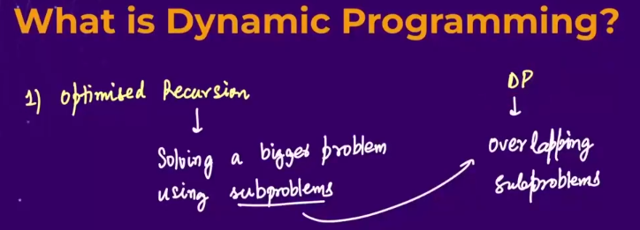

* DP is similar to recursion 🡪 In recursion we, solve a bigger problem using a subproblem by recursively calling it.
* DP is **optimized recursion** 🡪 when the subproblems start to **overlap**(mtlbb ek hi chiz baar baar calculate ho rha ho), then we use Dynamic programming.

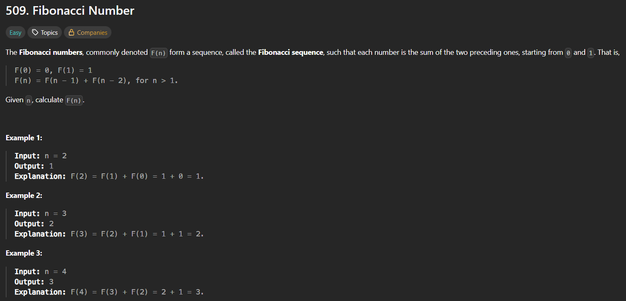

* Method 1 🡪 using recursion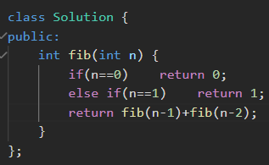 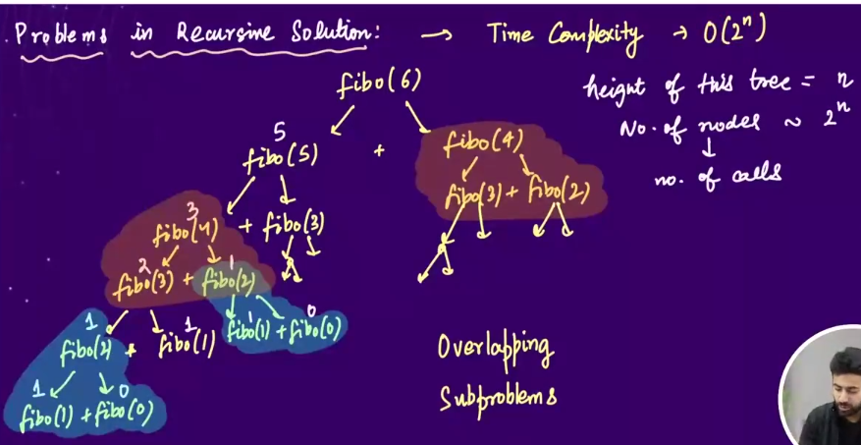 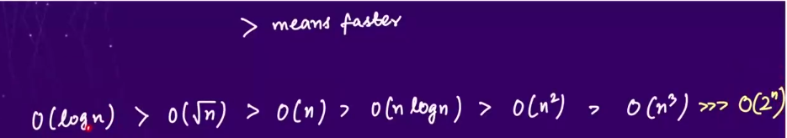
* Method 2🡪using iteration (with extra variable) 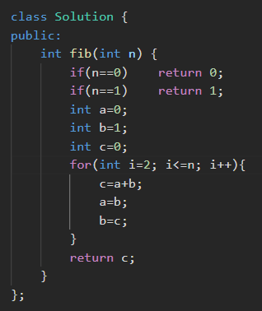
* Method 3🡪 using iteration (without extra variable) 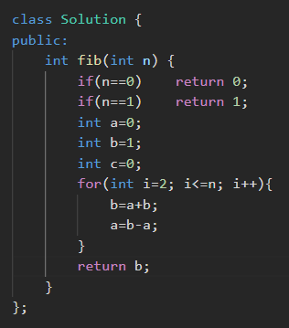
* Method 4🡪using DP🡪 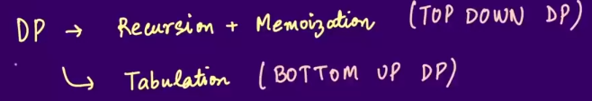🡪the problems in recursive solutionis that those solutions have Time complexity in the order of (2^n) and we always calculate those unnecessary things that we have already calculated earlier , this problem is called **overlapping subproblems** . And this problem can be solved by using DP. In DP also , we have two methods 2 solve the problems
  + Method 4.1 🡪 Recursion + Memorization (Top Down DP)
  + Method 4.2 🡪 Tabulation (Bottom up DP)
* Method 4.1 🡪 Recursion + Memorization (Top Down DP)

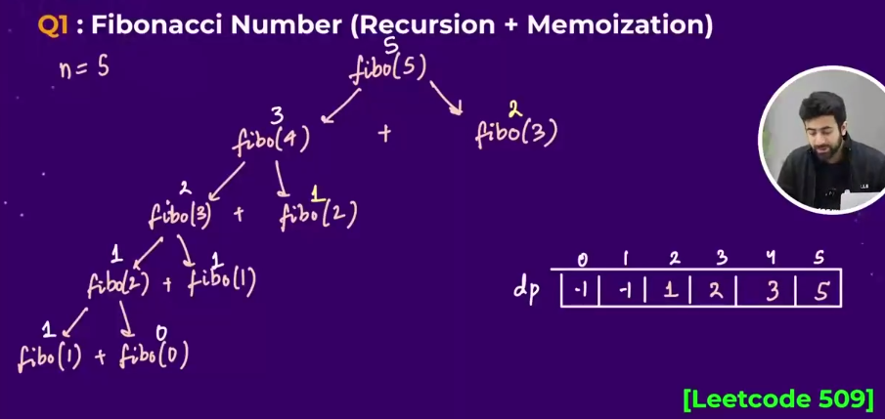 🡪In this method we make an array and store each of the value in the array and jb dobara who value calculate krne k liye aayega , then hm pehle array m check krenge ki who value present h ya nhi,

* + agar present hua then, we will escape from the recalculation and can use that value whenever needed
  + agar present nhi hua then, we will store the value in the array. 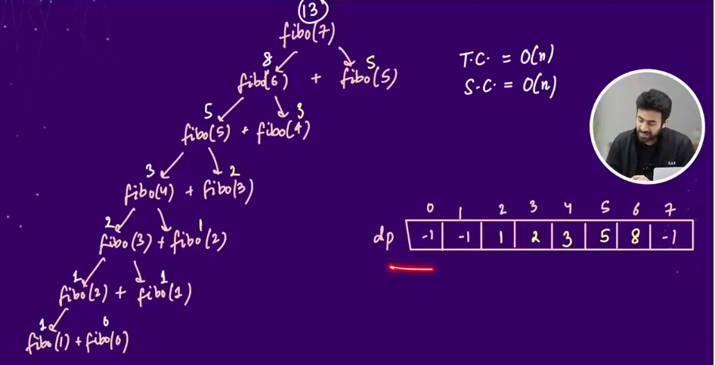🡪we can see in this example , that hme bhoot kchh calculate nhi krna parta isme.
  + 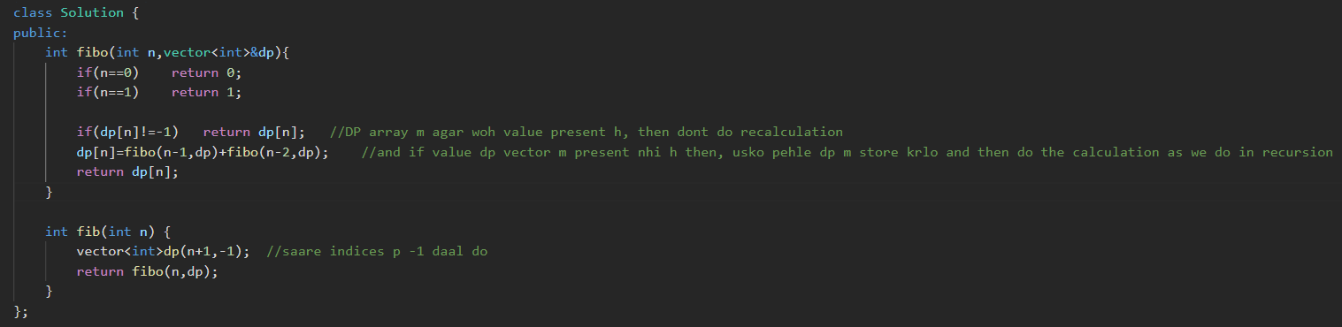

Or, 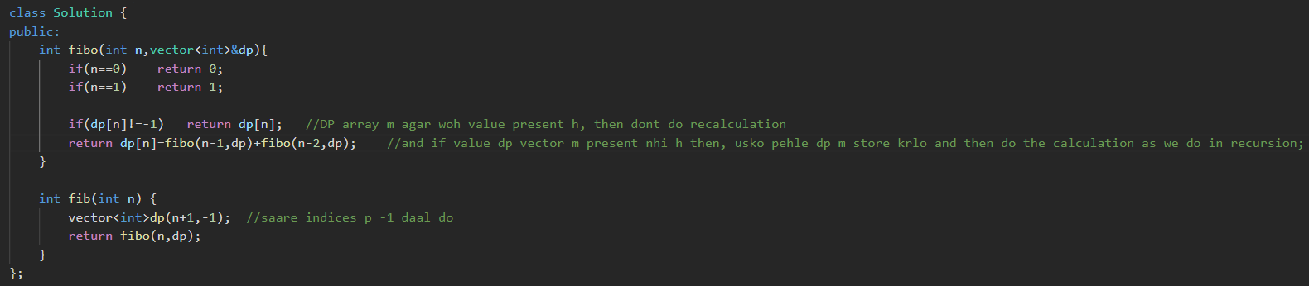

* Method 4.2 🡪 Tabulation (Bottom up DP)🡪in this we make an DP array and base cases ko pehle hi array m store kr lete h, and by loops we calculate the next value.

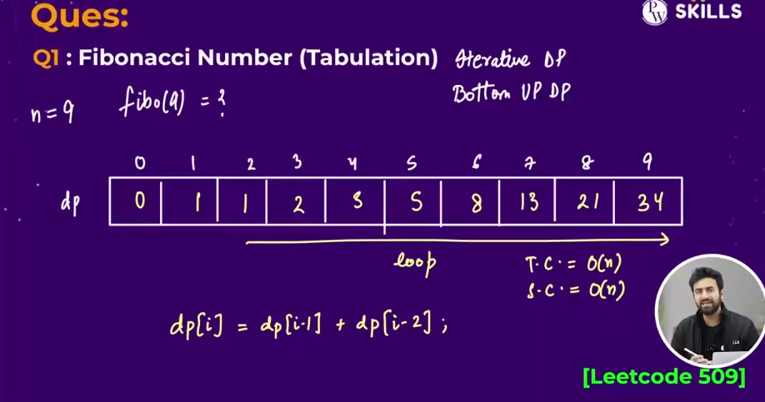 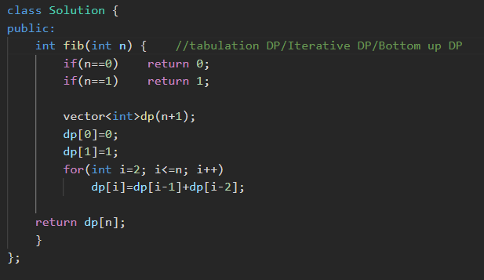

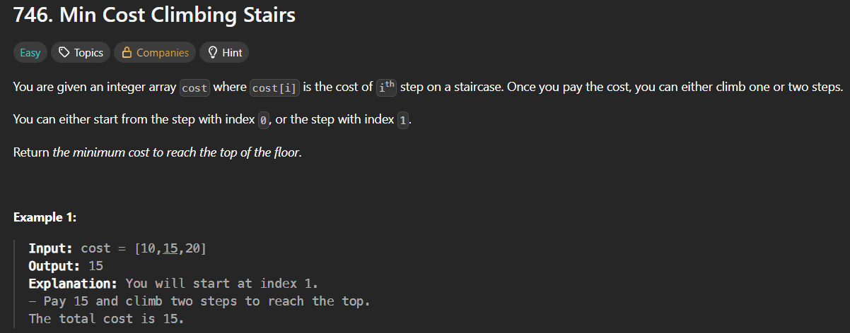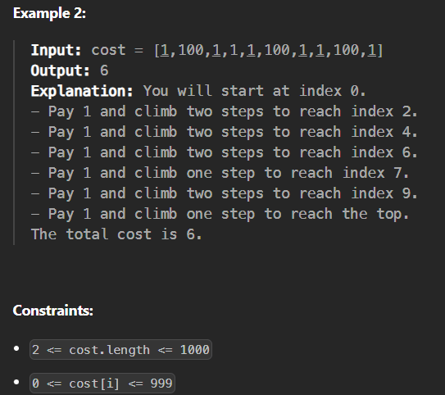

* 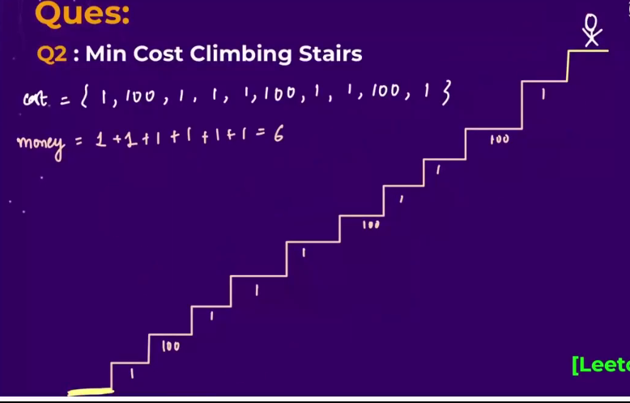
* 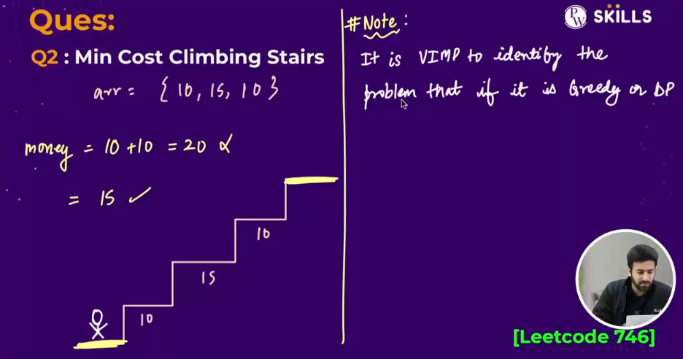
* I thought the solution greedily 🡪mincost nikaalke , har 2 seedhi and krte jaayenge, but that’s not working🡪that’s incorrect method
* Method 1 🡪recursion🡪but shows time limit exceeded🡪 similar to mine thought(above written), but in this we 🡪 we will calculate the minCost for both staring from 0th stair and 1st stair and return the minimum of these two and aaage similarly adhte jaoo.
  + 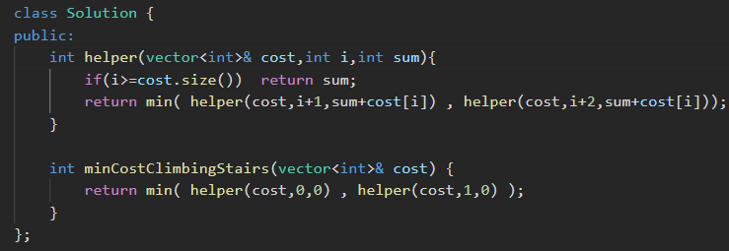
* Method 2🡪 recursion + memoization🡪same as above , bs isme last se start kro and use the DP and in **dp we will store the minimum cost to reach ith stair**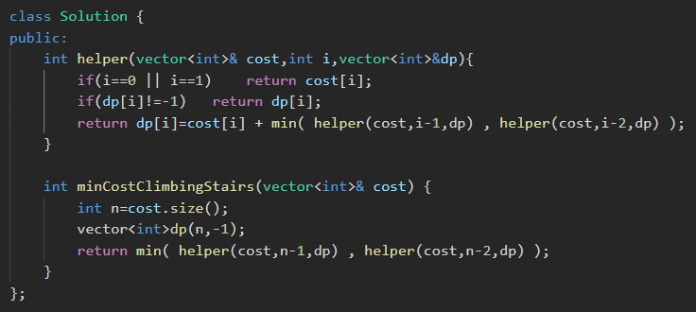
* Method 3🡪tabulation DP🡪**best method in this case**🡪in this we will calculate that kissi bhi seedhi p jaane ka minimum cost kitna hoga , by sitting at that stair. 🡪 we will start the loop from 2 and go to last, and will use the formula arr[i]=arr[i]+min( cost[i-1] , cost[i-2] )

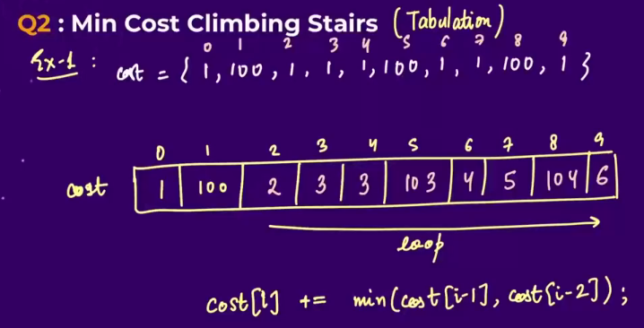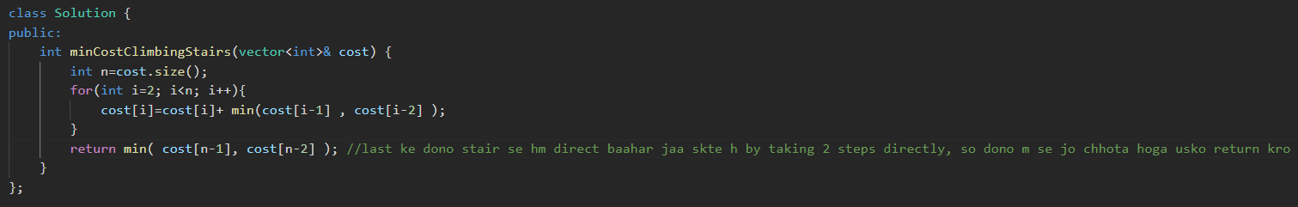

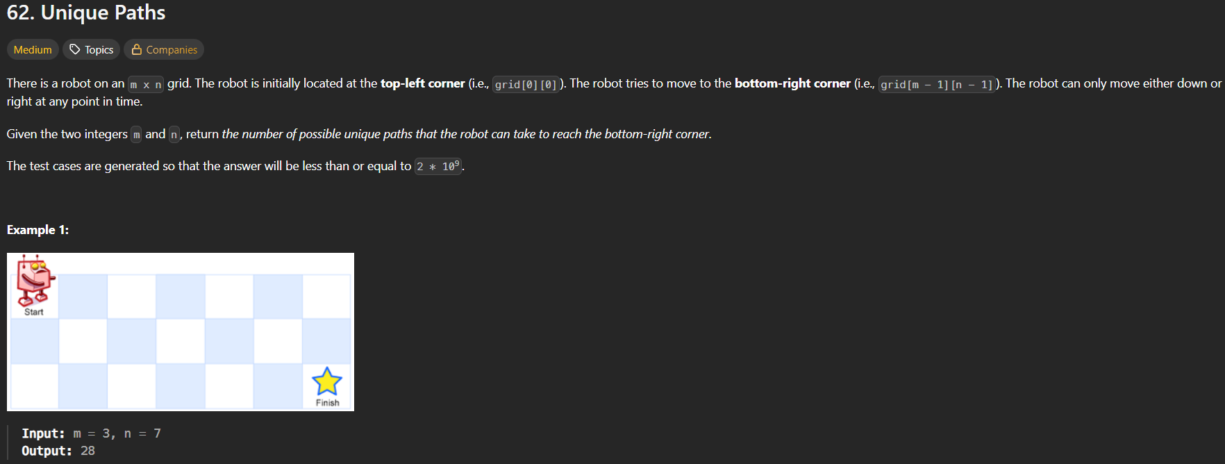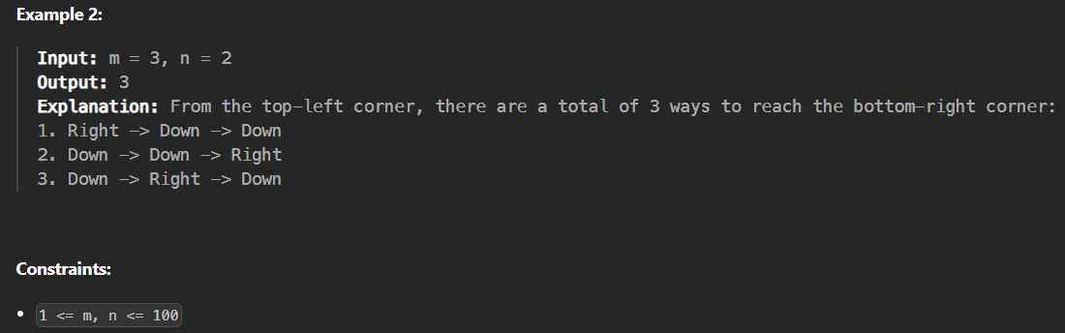🡪this question is similar to maze path question 🡪 see the logic in c copy.

* Method 1🡪recursion 🡪move from start 🡪see logic from maze path question in c copy 🡪 shows Time limit exceeded
  + 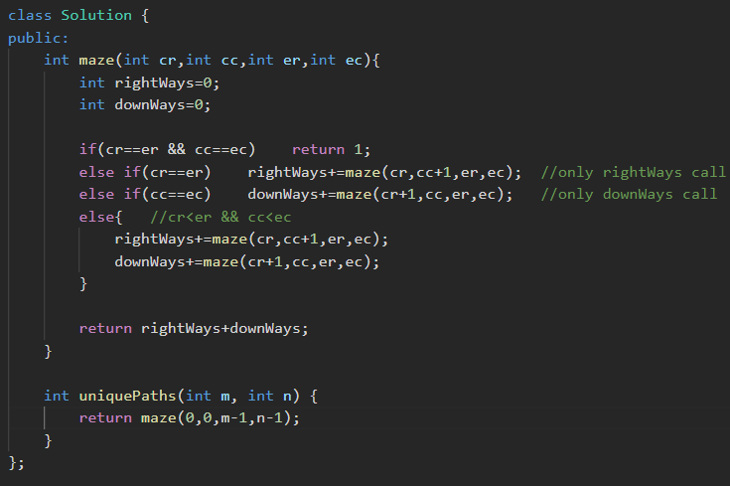
* Method 2🡪recursion 🡪move from end 🡪see logic from maze path question in c copy 🡪 shows Time limit exceeded

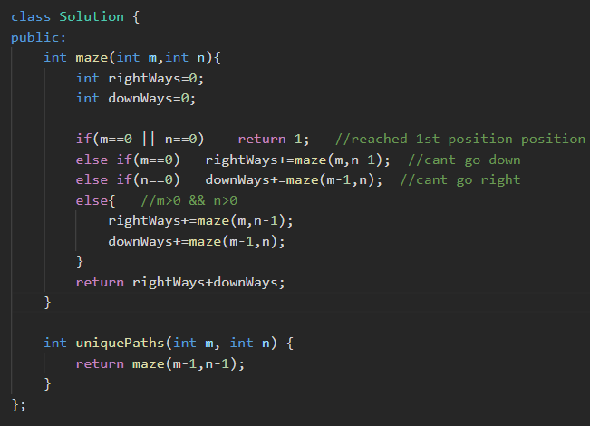

* Method 3🡪 recursion 🡪 see logic from maze path question in c copy 🡪 shows Time limit exceeded

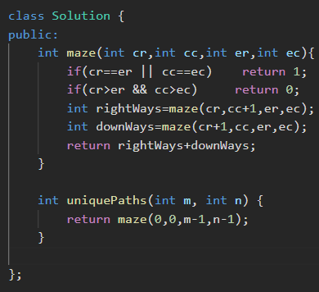

* Method 4🡪using DP🡪 recursion+memoisation

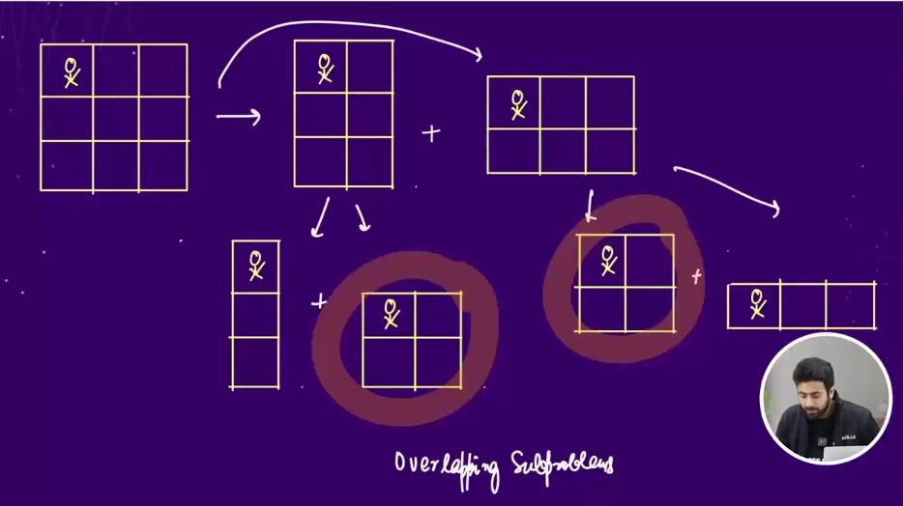 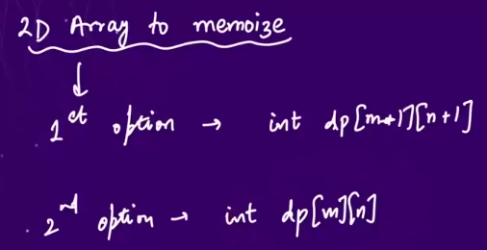 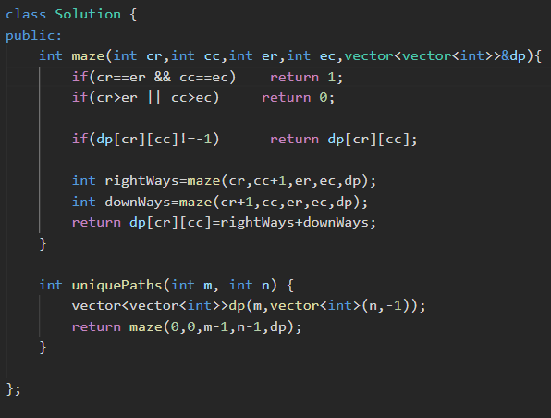

* Method 4🡪using Tabulation🡪best method🡪we will make a 2D array named DP and in each box we will store ki uss box tk aane k kitne raaste h.
  + In row=0 or column=0, har box m pahuchne ka sirf ek hi raasta hoga, becoz only two moves are possible 🡪either move rightWays or downWays
  + Except the row=0 ar column=0 , baaki inner boxes m jaane k liye =
    - ways to reach just upr waala box + ways to reach just neeche waala box
    - i.e dp[i][j] = dp[i-1][j] + dp[i][j-1]
  + at last return dp[m-1][n-1]
  + 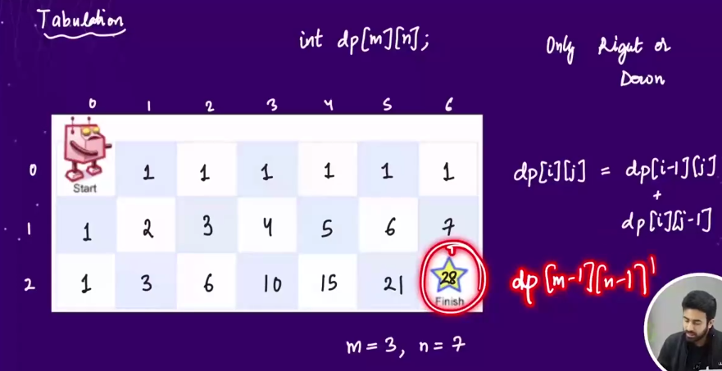 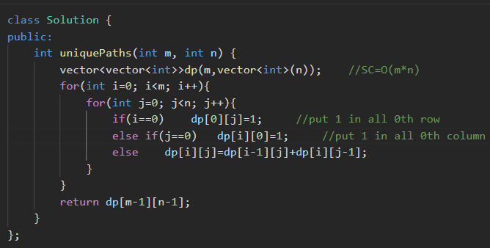

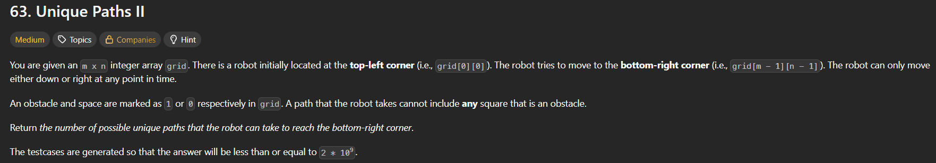 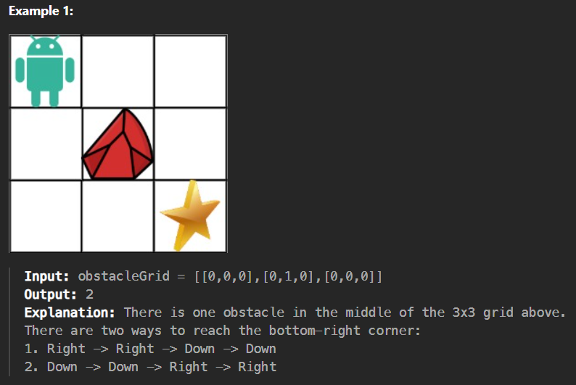 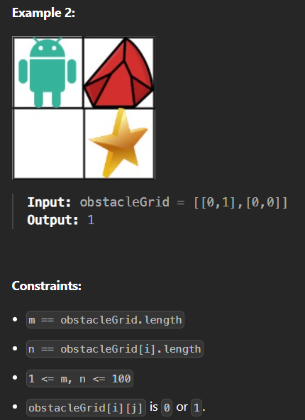🡪similar to above question

* Method 1 🡪 Tabulation DP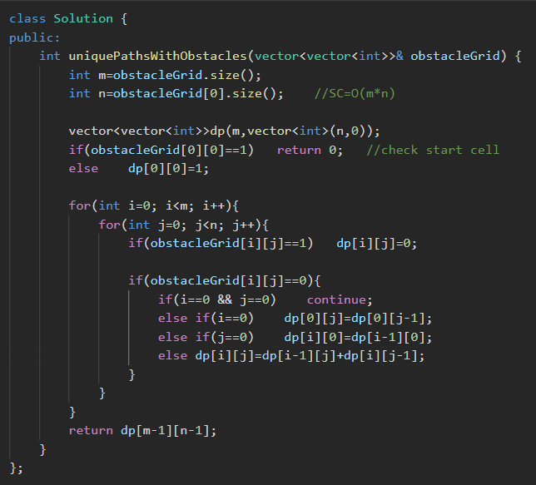

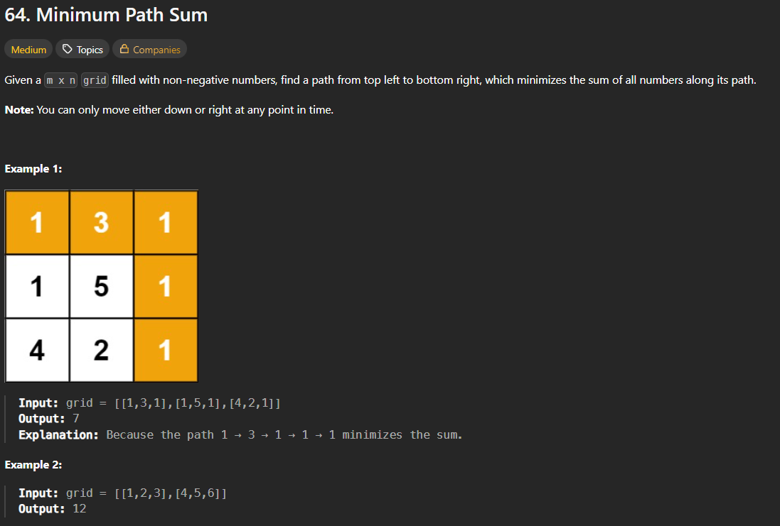🡪similar to above question

* Method 1🡪tabulation DP🡪 Algorithm 🡪har ek cell m jaane ka cost nikaal lo from starting position , by taking the minimum value from the above path and left path. 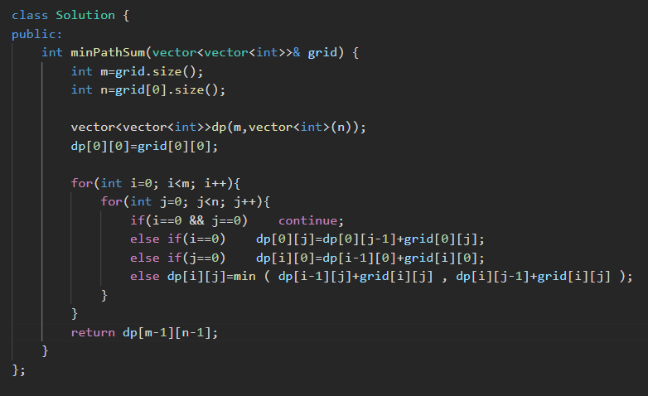

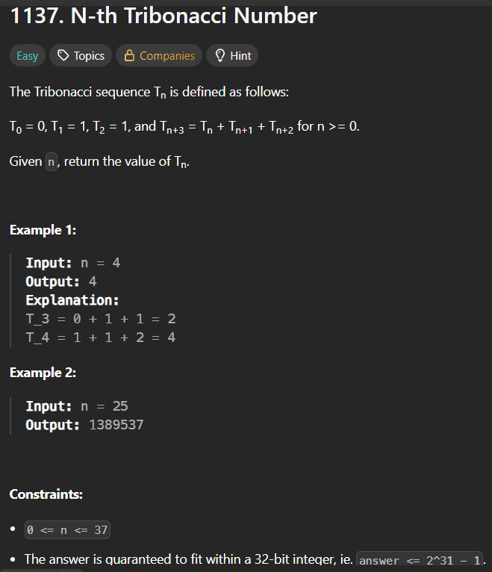

* Method 1🡪Using recursion 🡪time limit exceeded tribonacci tribonacci 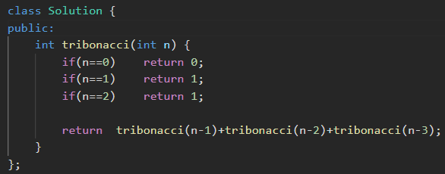
* Method 2🡪Recursion + Memorization (Top Down DP)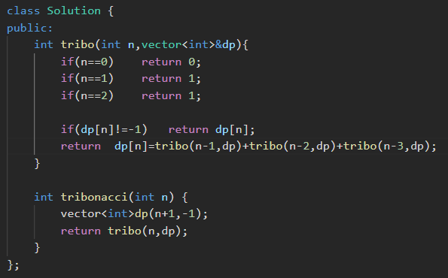
* Method 3🡪tabulation

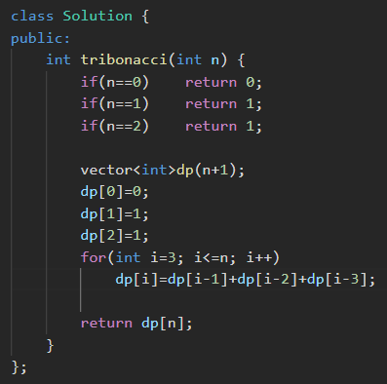

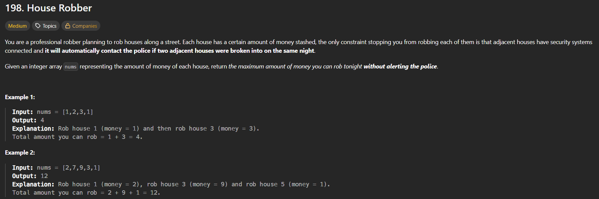

* My thought 🡪 wrong logic🡪passes in 40 testCases but fails in 30 test cases 🡪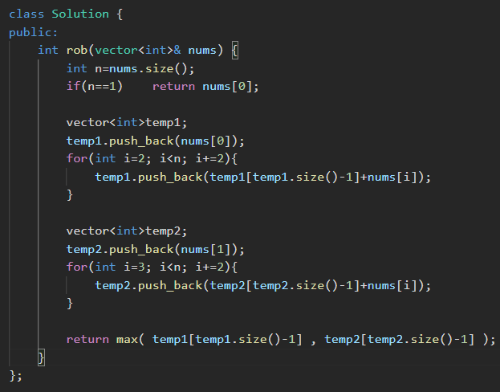

**❌ Why this logic is WRONG (core concept)**

Your approach assumes:

“Rob either all even-index houses or all odd-index houses.”

That is **not how House Robber works**.

**Counter-example (very important)**

nums = {2, 1, 1, 2}

Your logic:

* even houses → 2 + 1 = 3
* odd houses → 1 + 2 = 3

Correct answer:

2 + 2 = 4

So **even/odd splitting fails** ❌

* Method 1🡪recursion🡪 kissi bhi ith index ko choose krne ka 2 hi option h, ya to usko chhose kro ya mt kro.

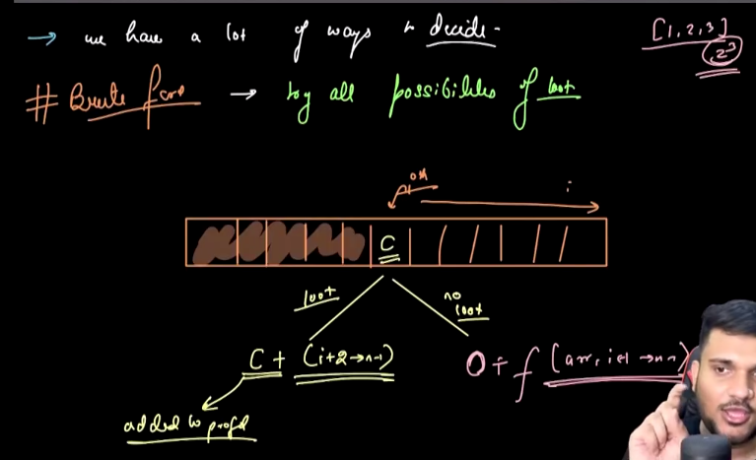 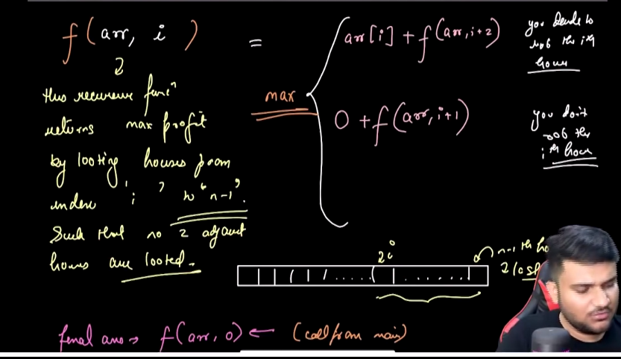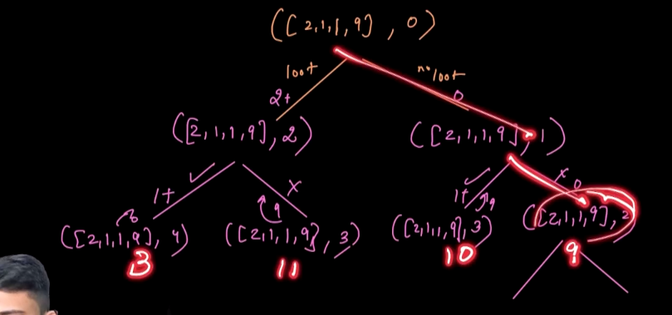 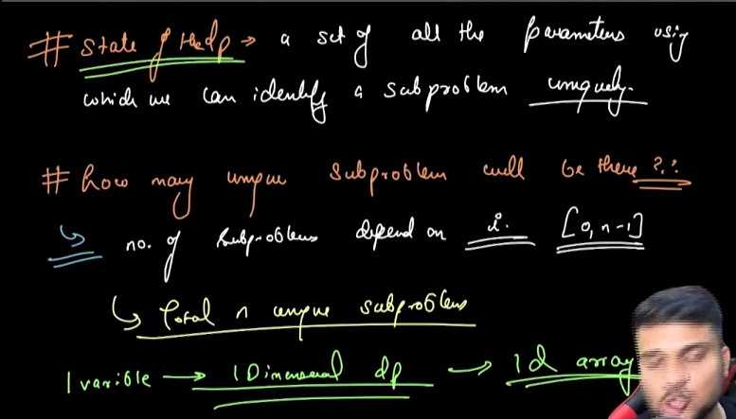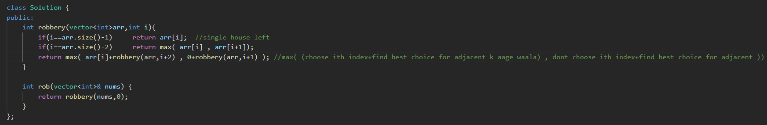 

* Method 2🡪using DP🡪recursion+memoisation 🡪top down DP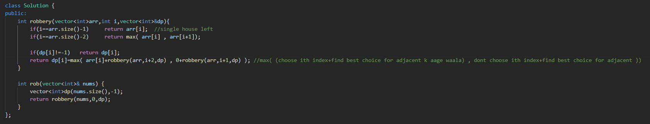
* Method 3🡪tabulation

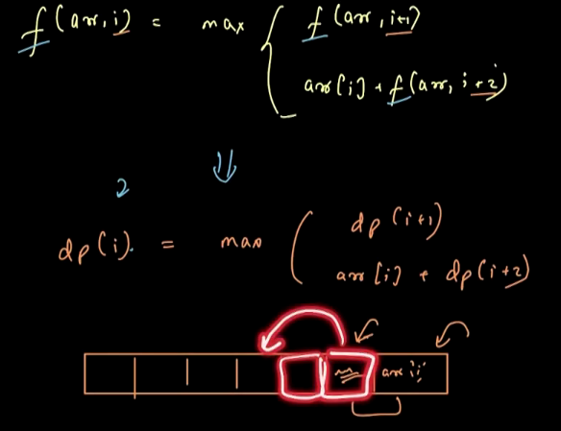 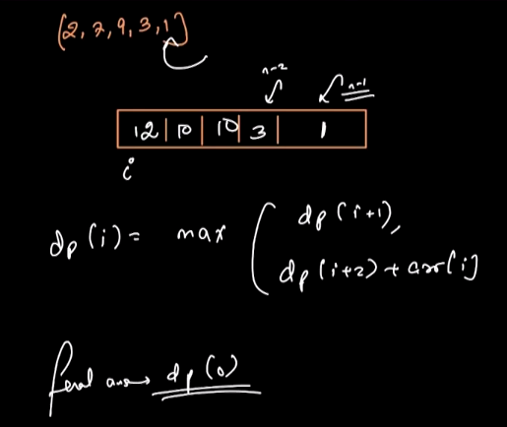 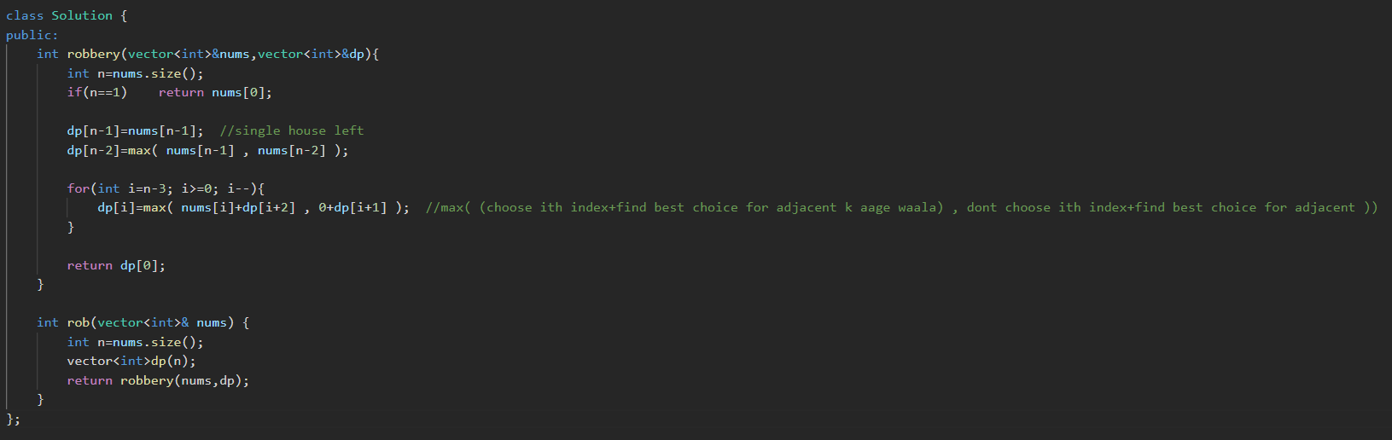

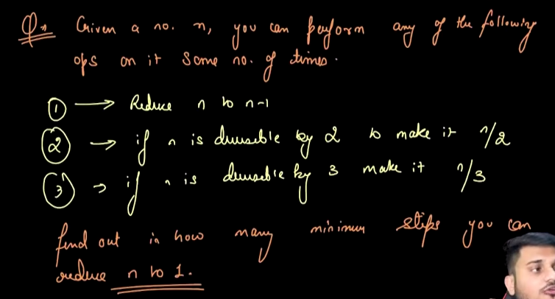 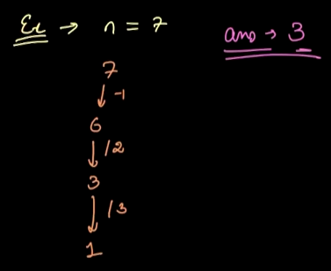

* Method 1 🡪greedy 🡪 will five wrong answer 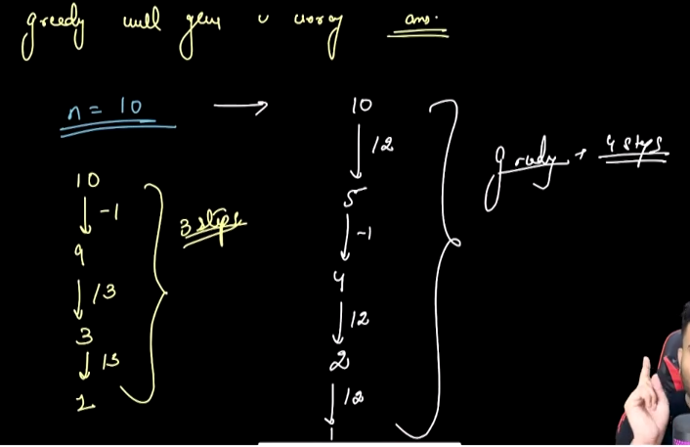
* Method 2🡪Recursion 🡪 (n-1) , n/2, n/3 se 1 tk jaane m kitna operations lgega yehh calulate kr lo recursiively and then tino m se jo minimum hoga usme 1 add krdo becoz uss step tk jaane m bhi ek step lg chuka h. 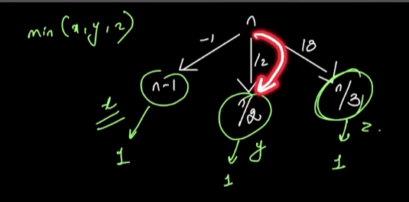 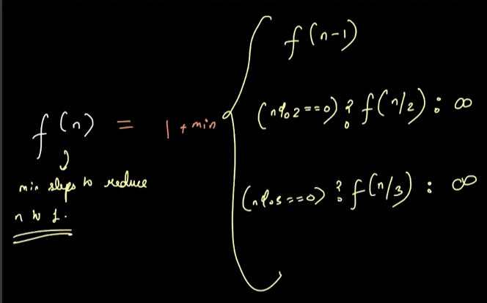 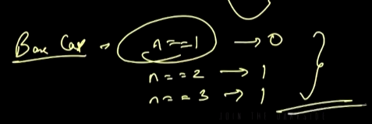

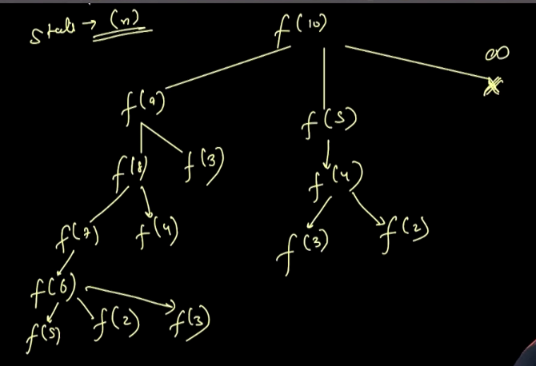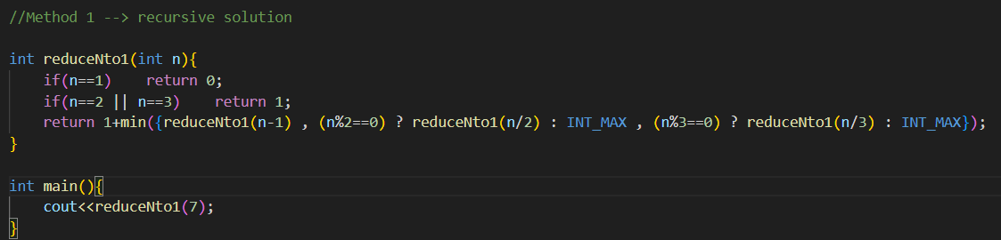

* Method 3🡪recursion + Memoisation DP 🡪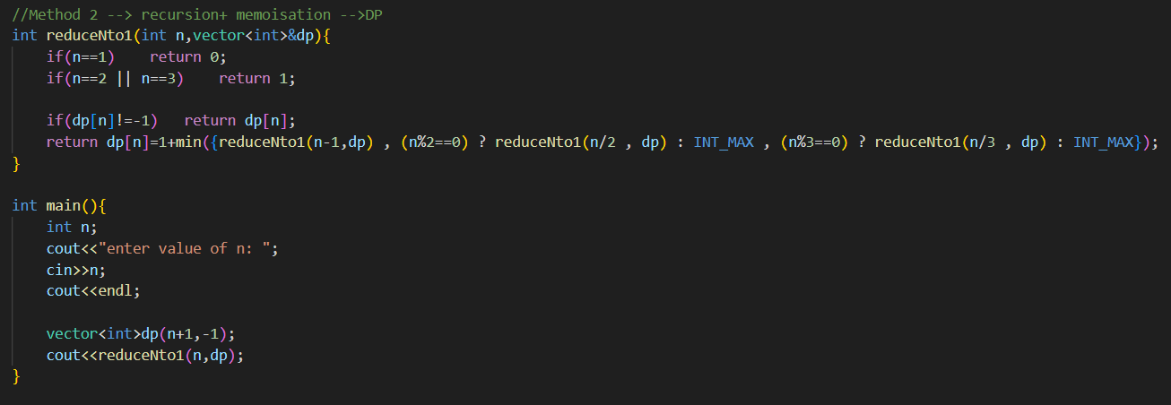
* Method 4🡪tabulation DP🡪

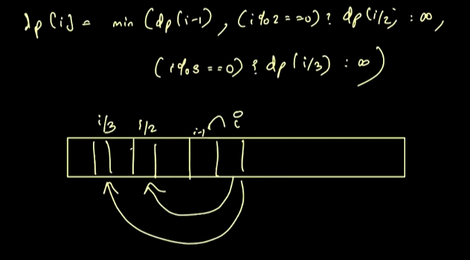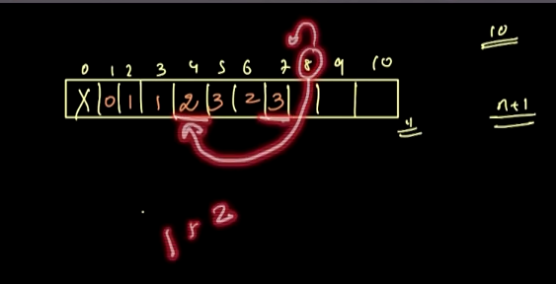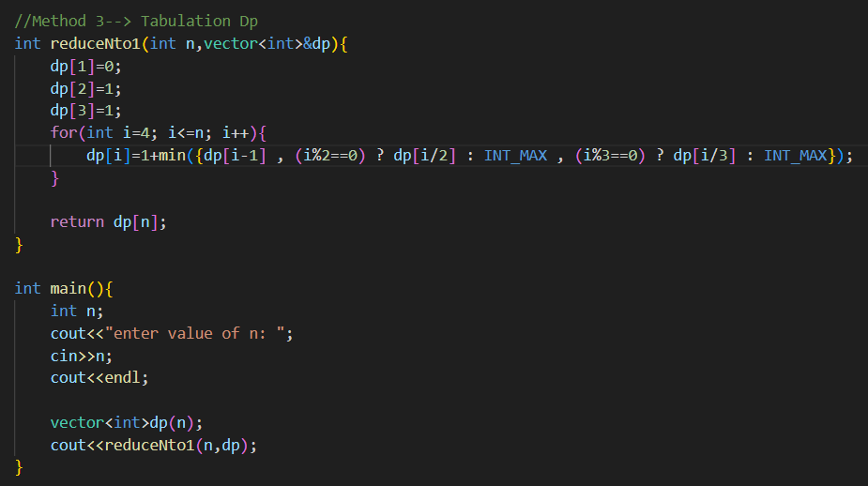

Note 🡪 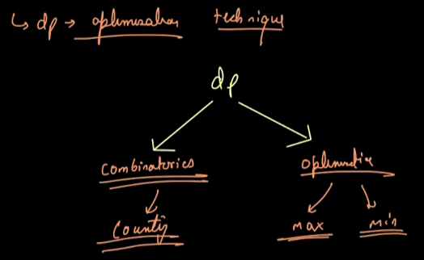

**My Observation ::**

* **To solve the problems of DP:**
  + **Method 1 🡪 recurseive solution 🡪 think and apply**
  + **Method 2🡪top Down 🡪recursion +memoisation 🡪 just store values in DP vector and paas it to the function and donts change anything else.**
  + **Method 3🡪bottom up 🡪bottom up🡪tabulation 🡪 just use the same logic of Method 2 , bs isme iteration lga do , and kchh stating and last k values ko find kr lo for the base cases , and saare n->i se replace kr do and jaha jaha recursion waala function use hua h, wha p bs dp vector se replace kr do**

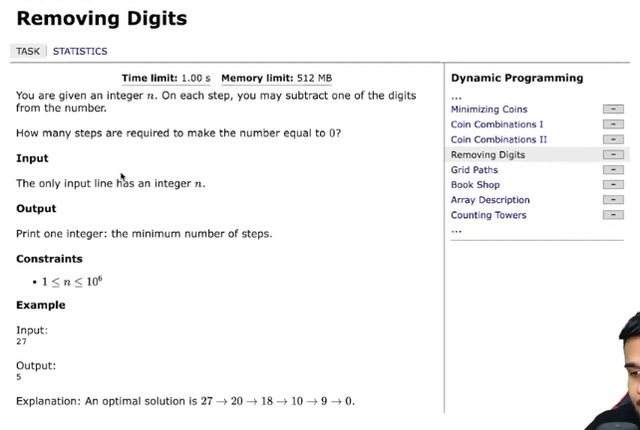

* 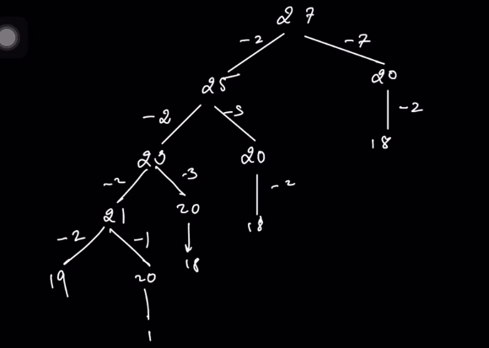
* Method 1🡪my method 🡪using priority queue (maxheap) 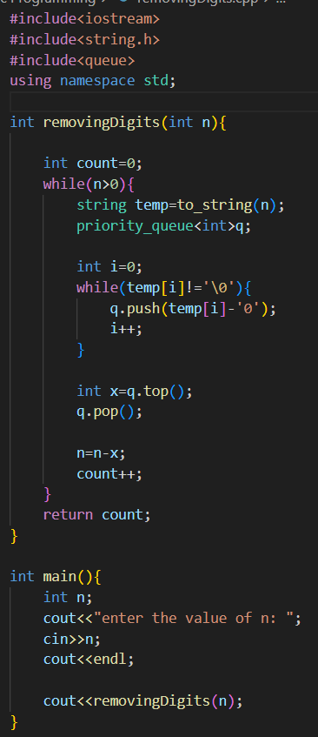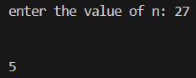
* Method 2🡪using recursion 🡪I am not able to understand the solution 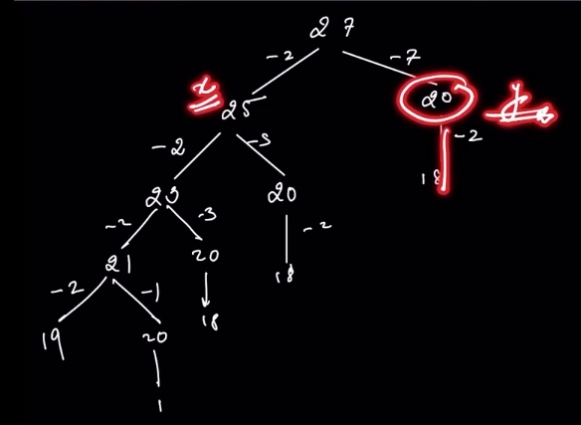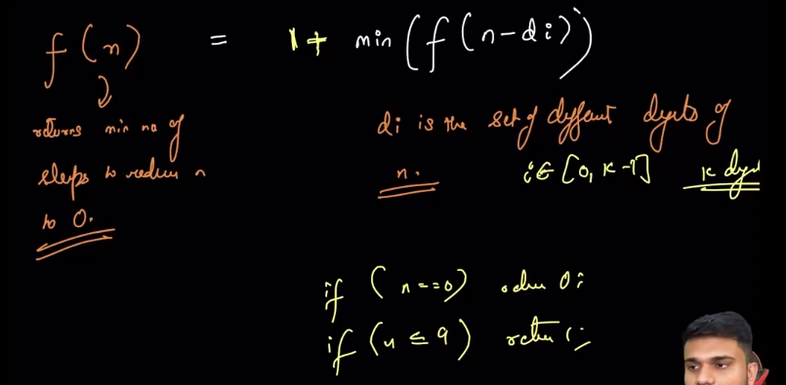

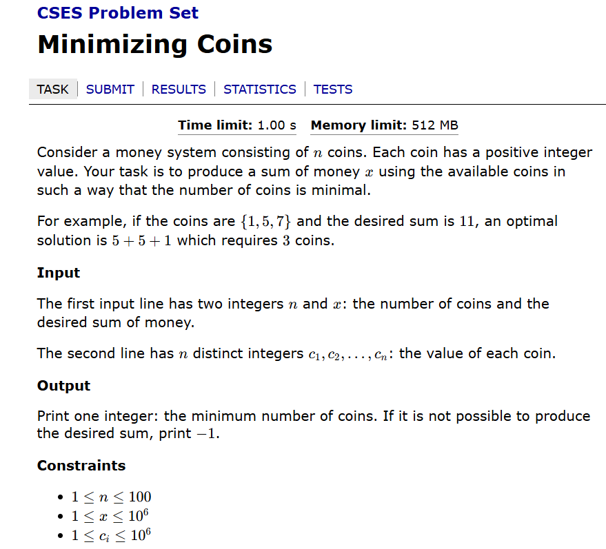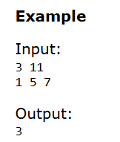🡪this question is same as leetcode 322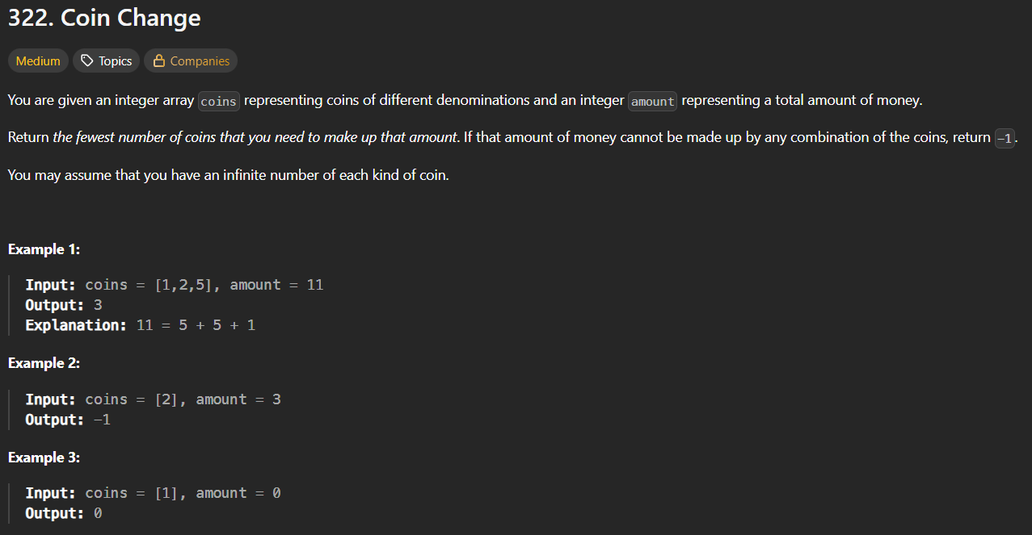

* Method 1🡪Greedy🡪will give wrong answer 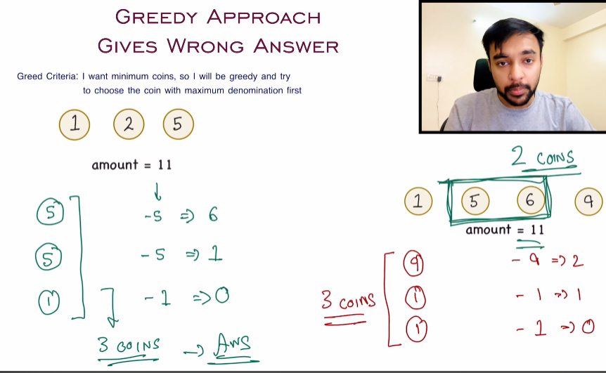
* Method 2🡪DP

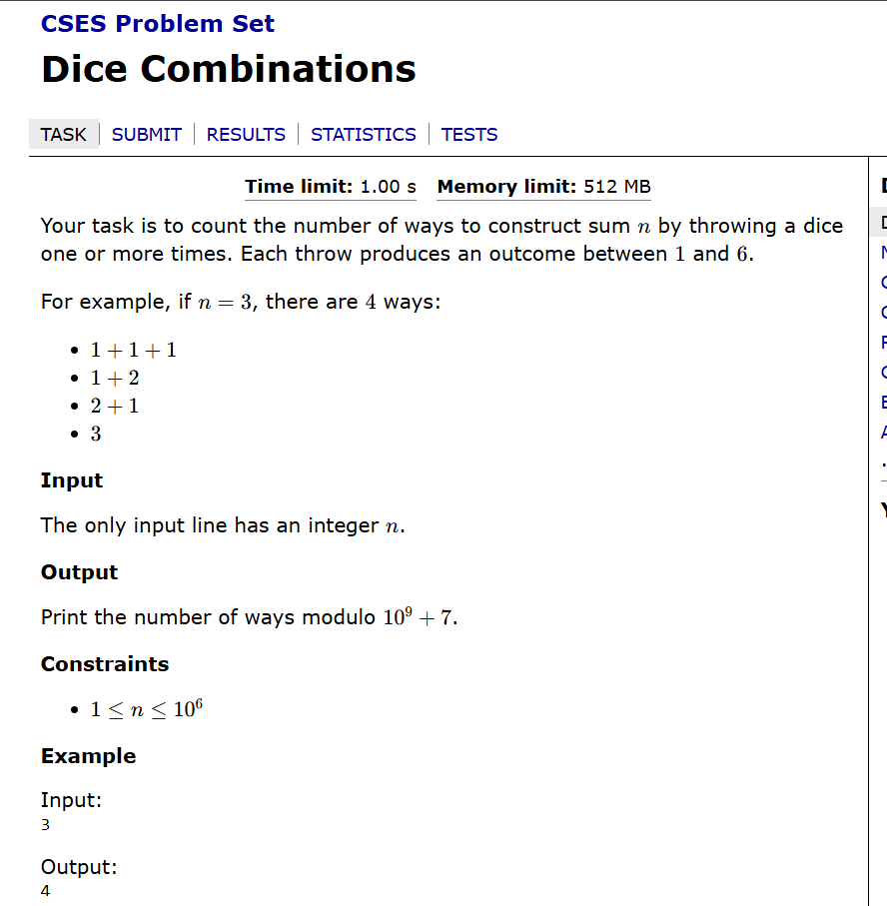

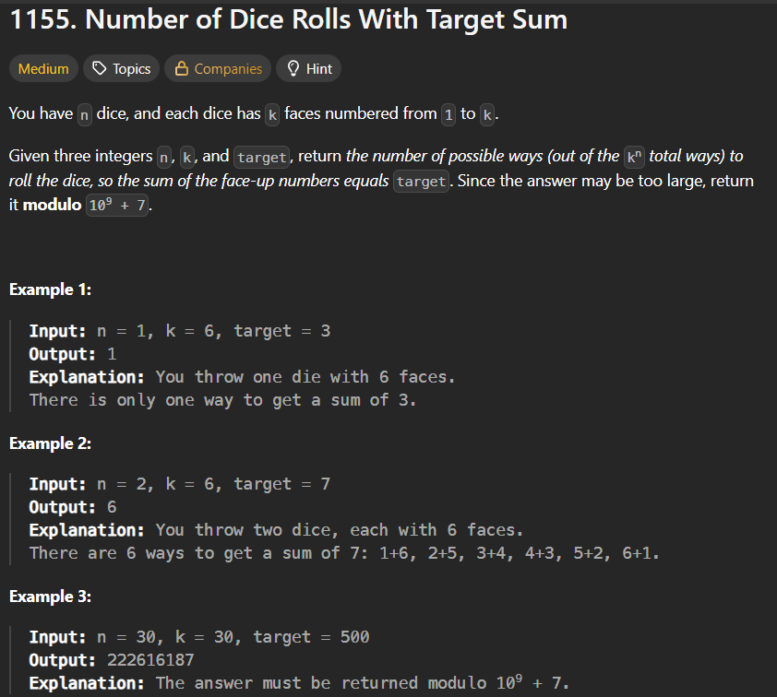

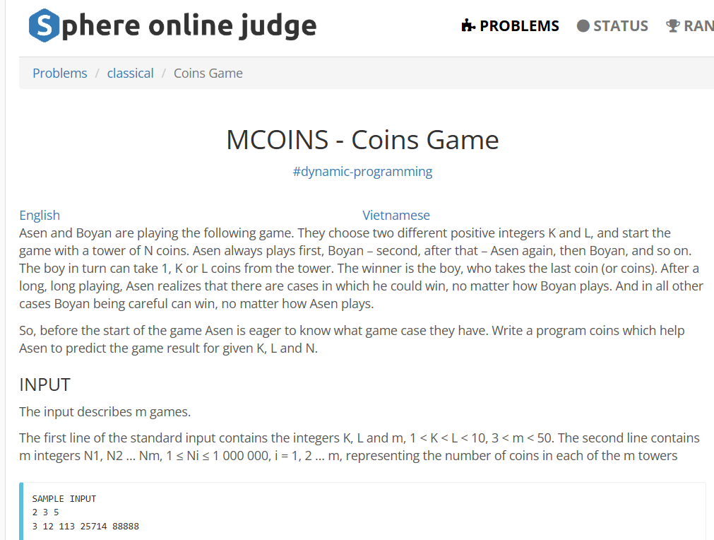 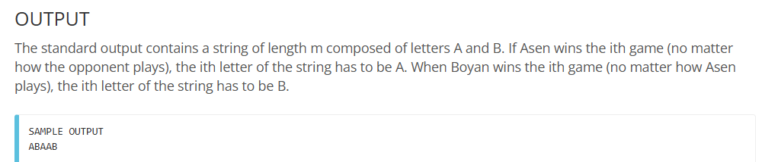

* 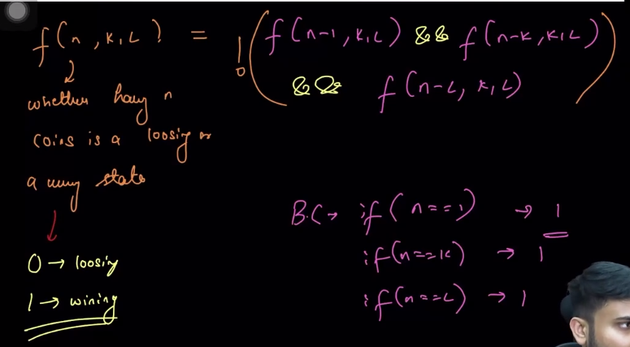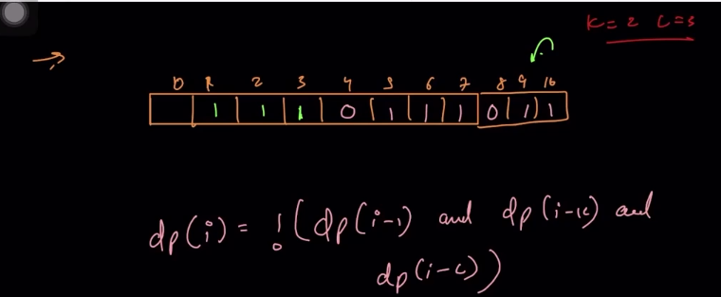

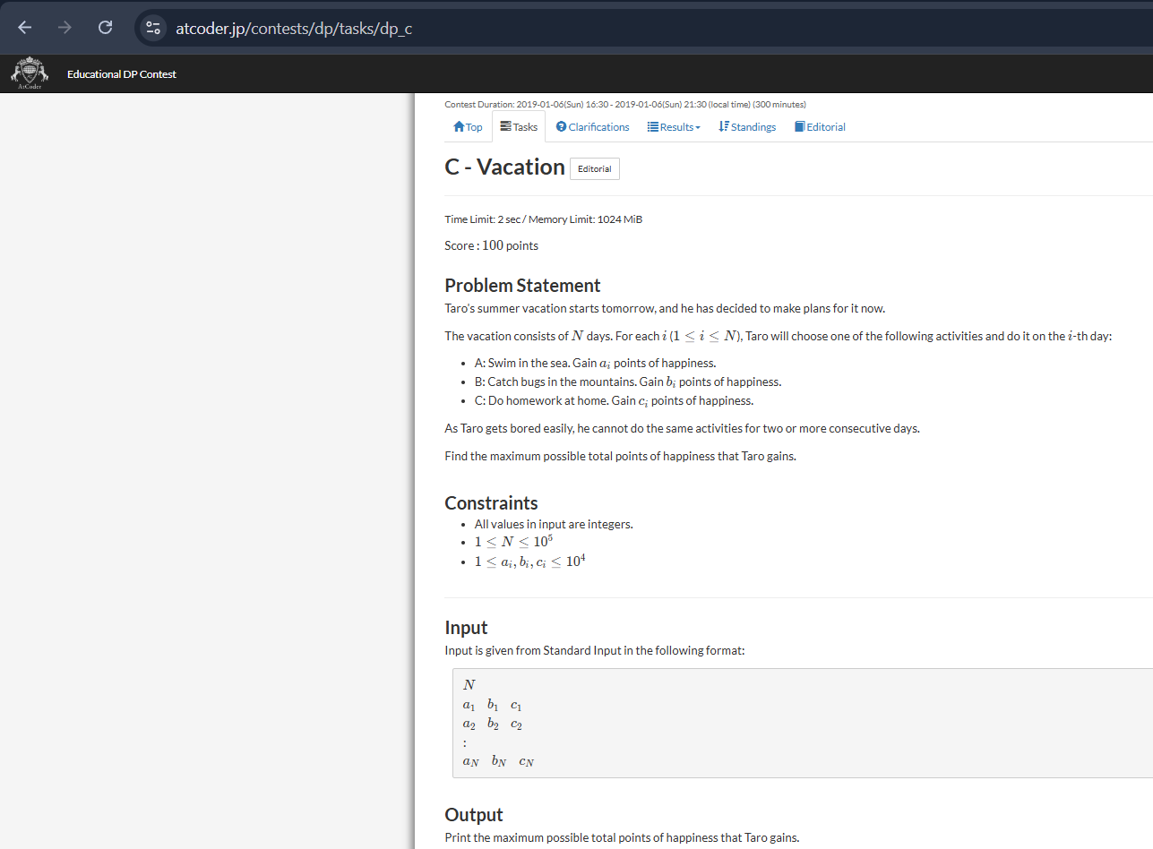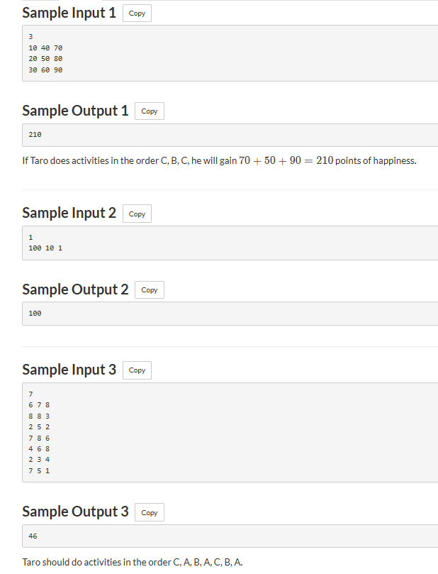

* 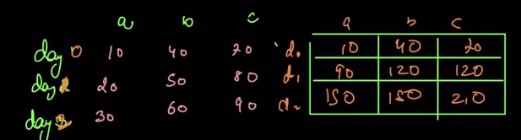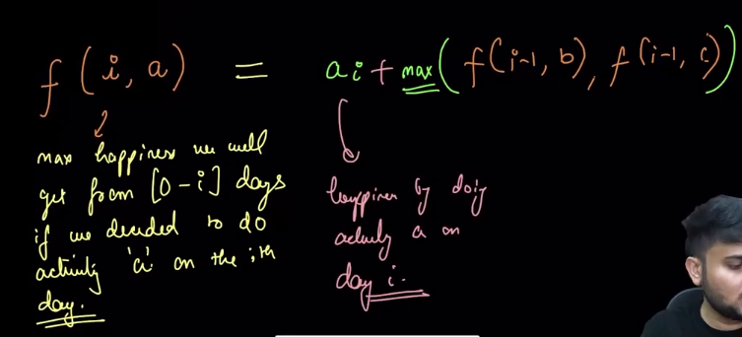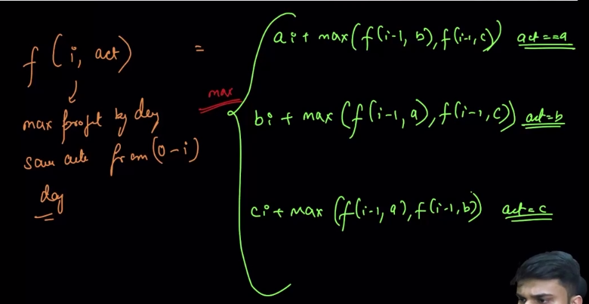

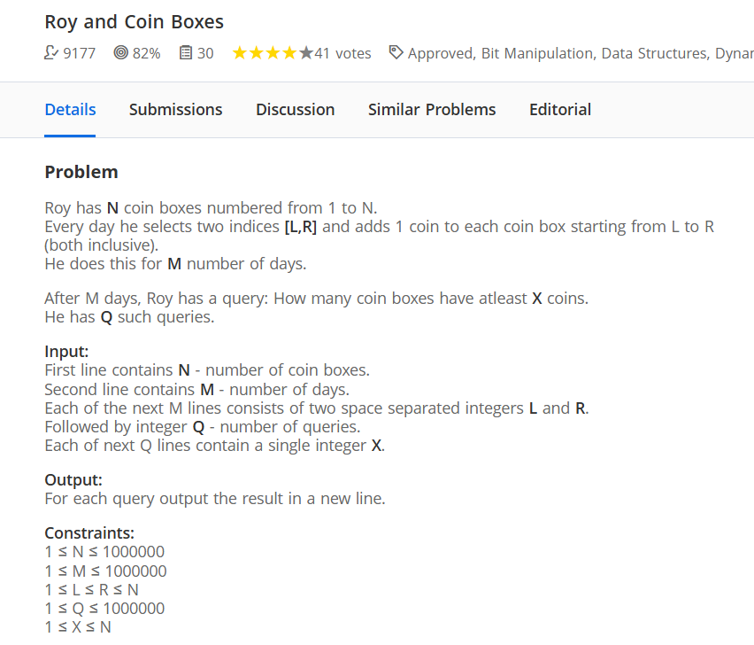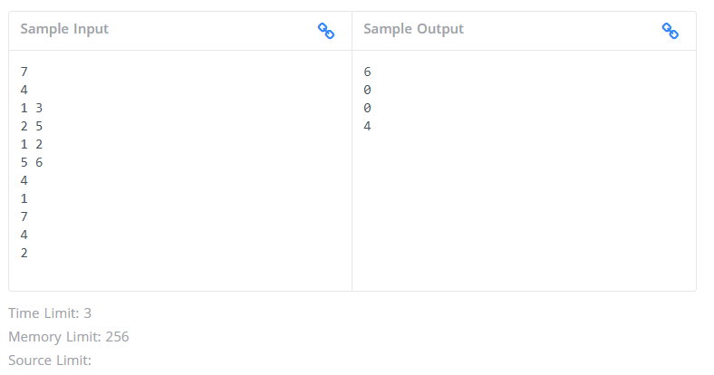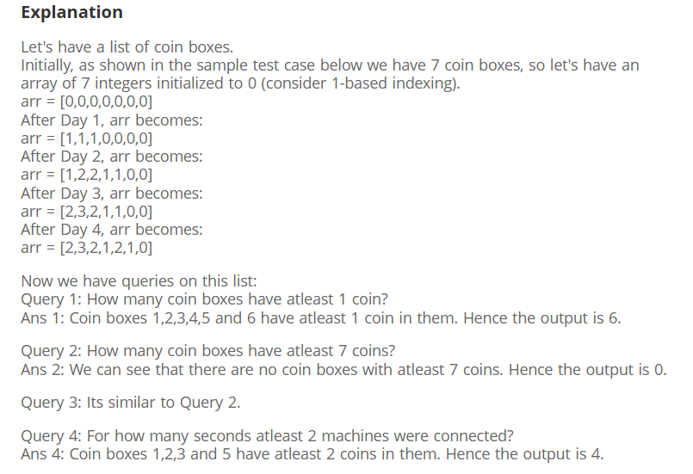

* Method 1🡪 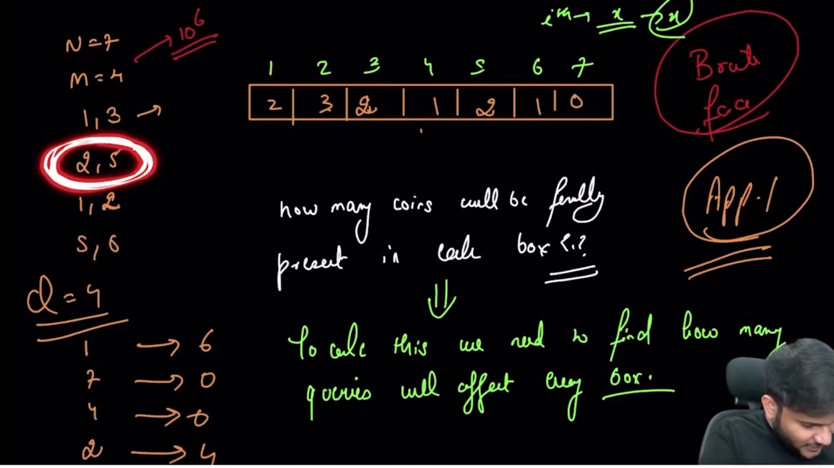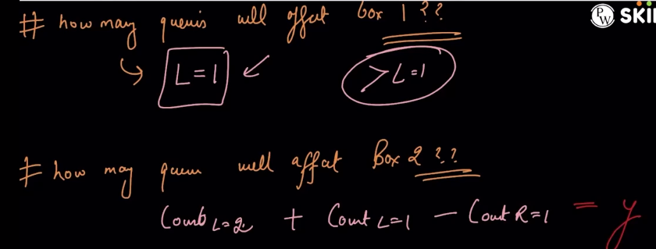

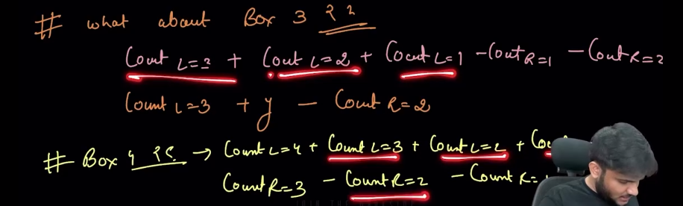

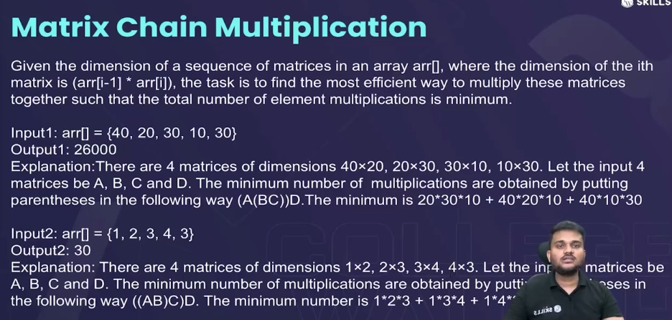🡪see notes in DP copy

* If the dimension of the two matrices to be be multiplied are **(a*b) and (b*c)**
  + Then the number of **multiplication operators** are : **a*b*c**
* Method 1🡪 using recursion🡪 time limit exceeded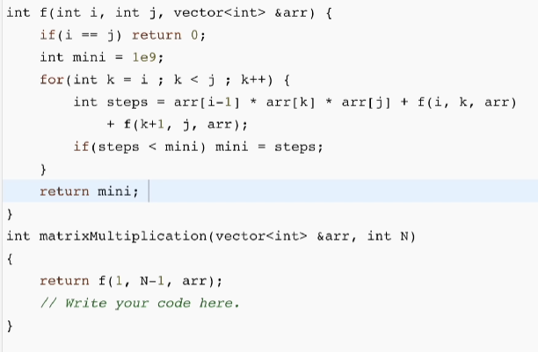
* Method 2🡪recursion+memoisation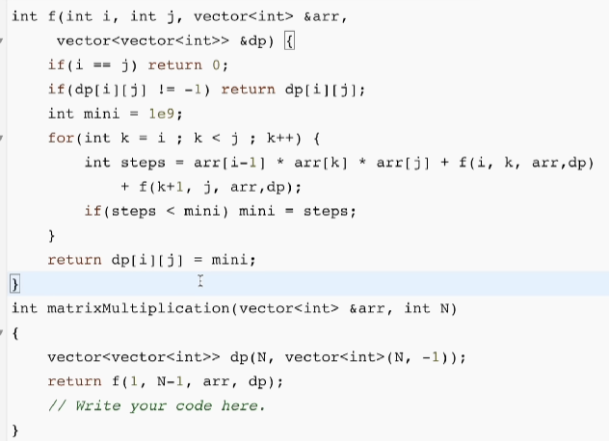
* Method 3🡪tabulation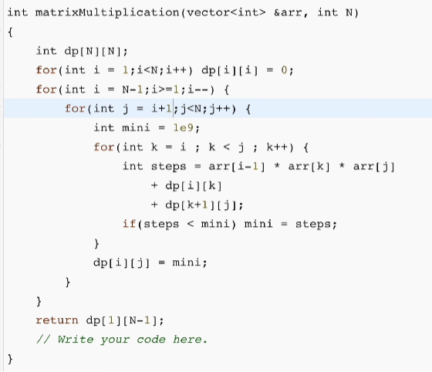

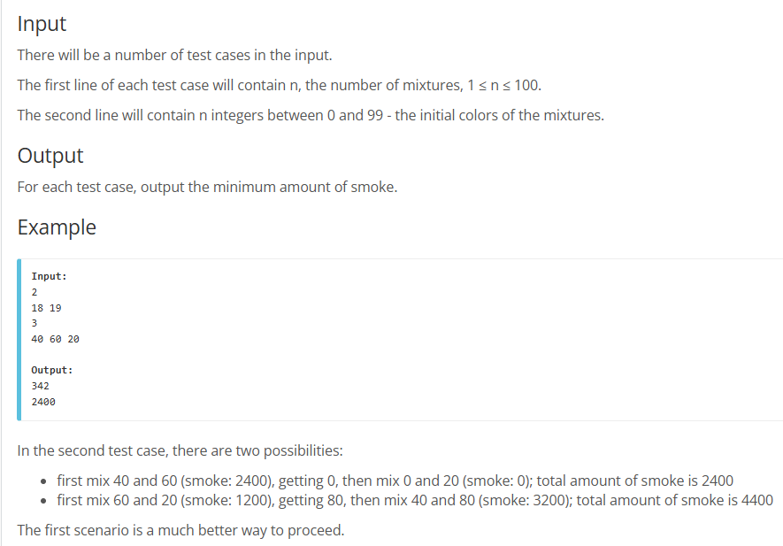

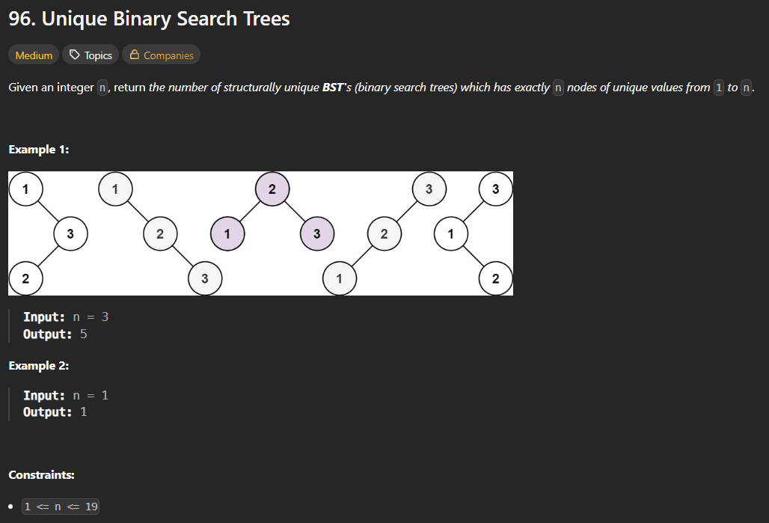

* 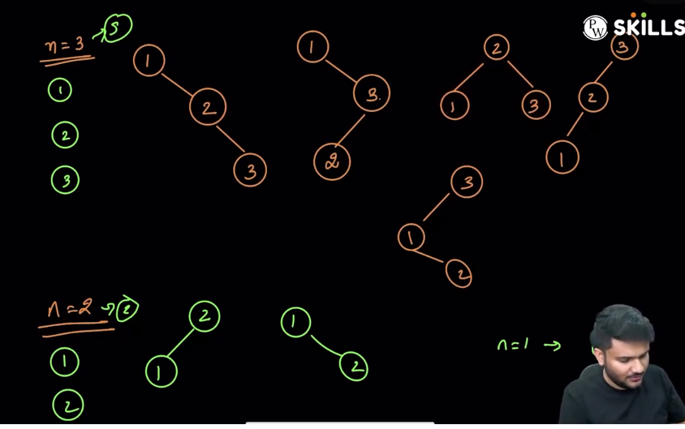
* Method 1🡪Recursion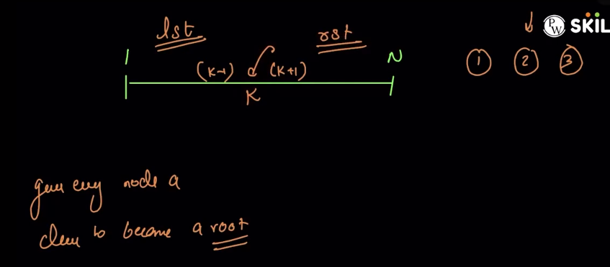🡪thought process🡪kissi bhi kth number ko root bnaayenge then, number of possible structures will be == (no. of ways to make 1 to k-1 trees)*(no. of ways to make k+1 to N i.e N-k)
  + 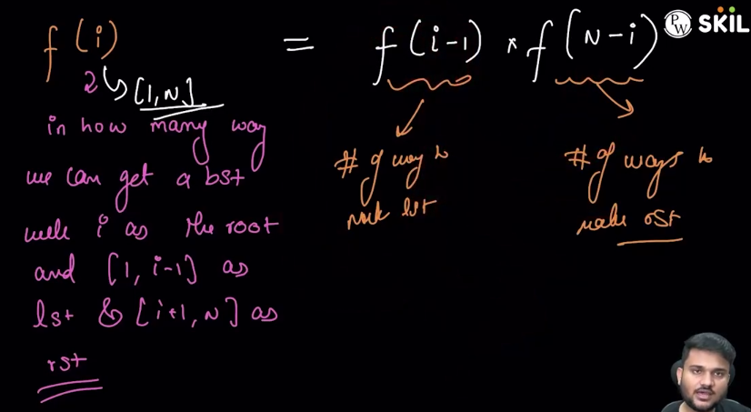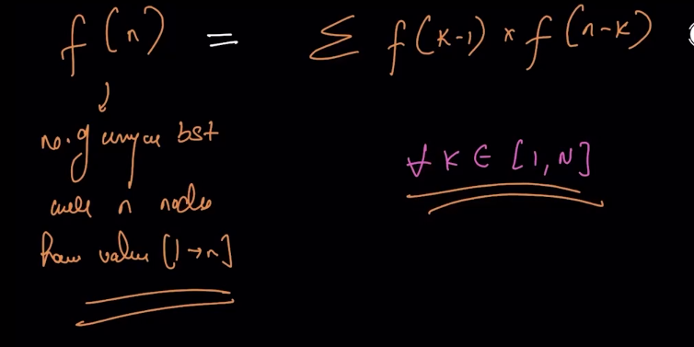
  + 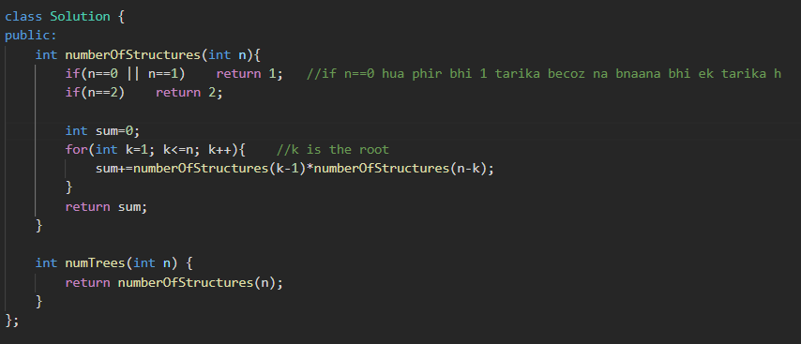
* Method 2🡪recursion + memoisation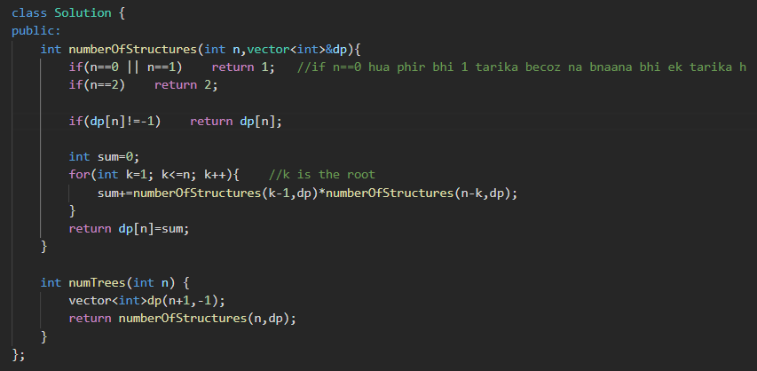
* Method 3🡪tabulation 🡪samajh nhi aaya h yehh waala , bs likh liye h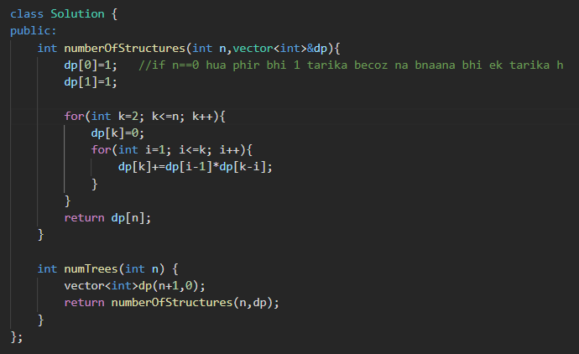
* Method 4🡪this question can also be solved using catalan number (a mathematical formula)

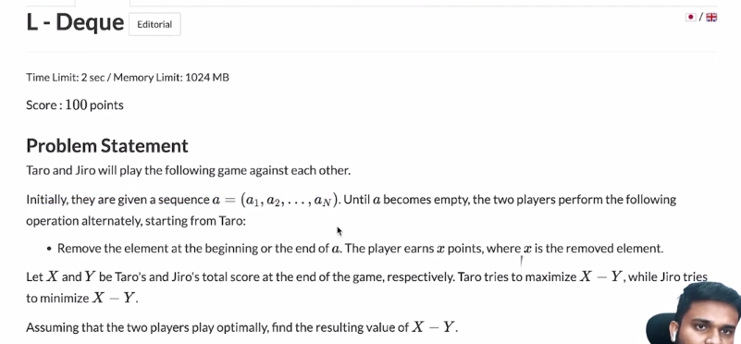

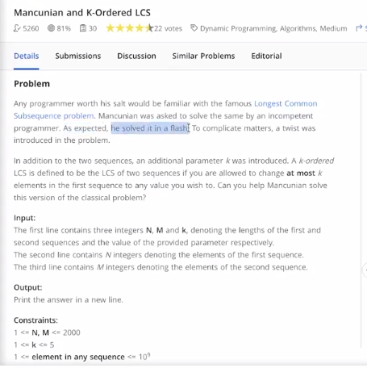

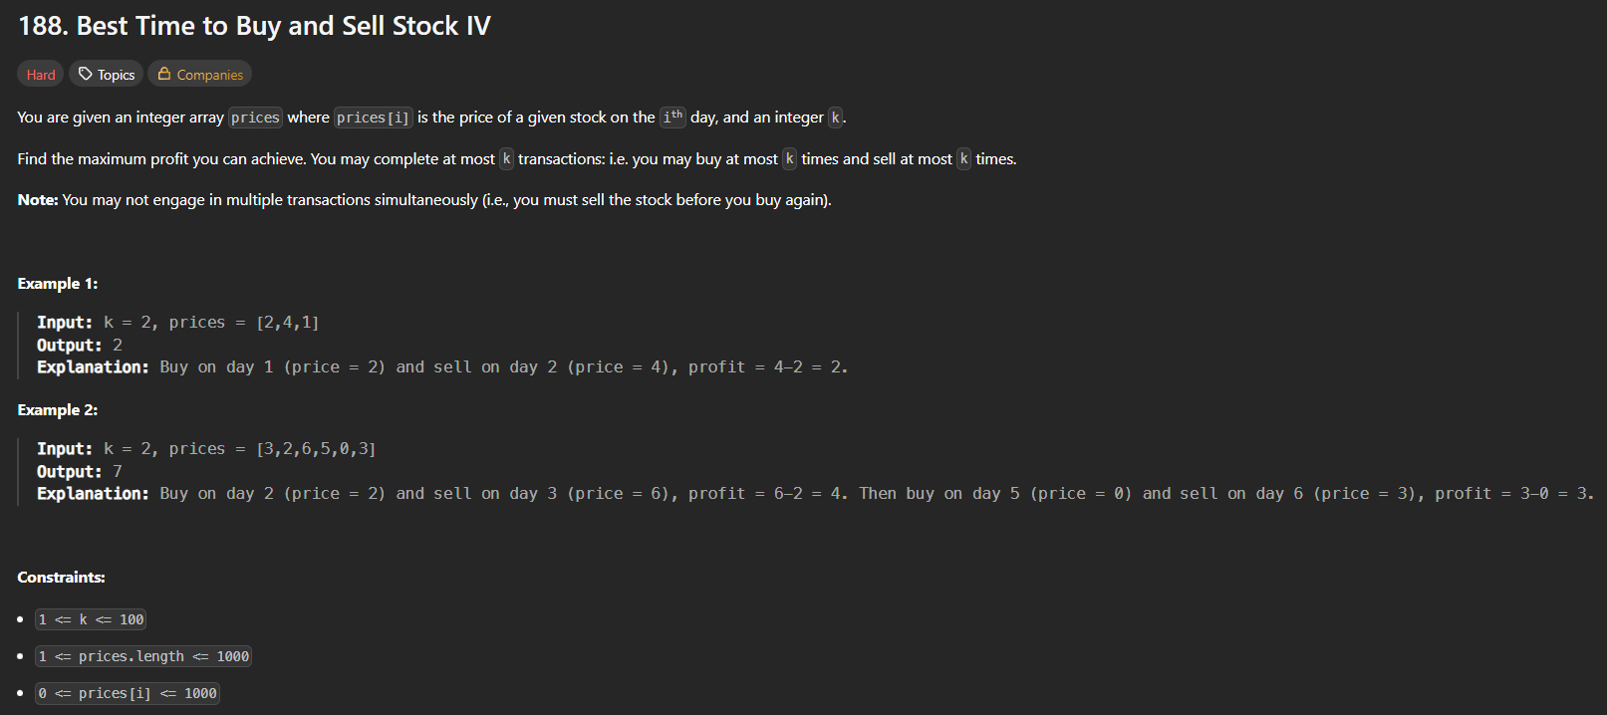

* 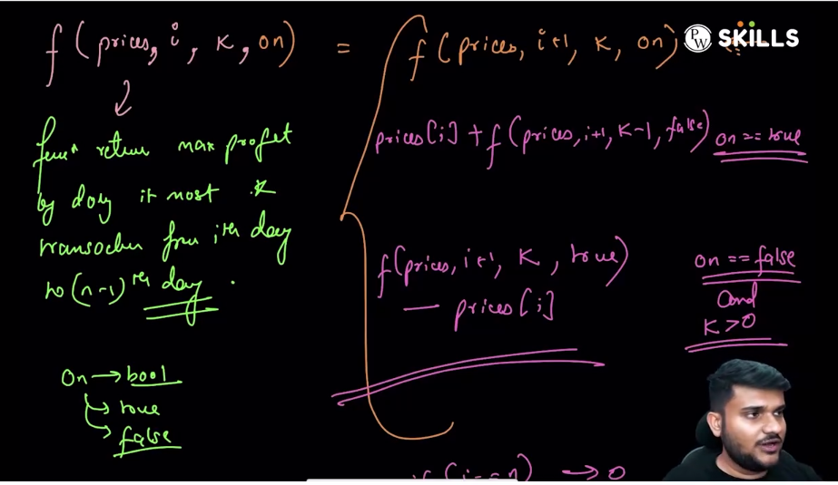

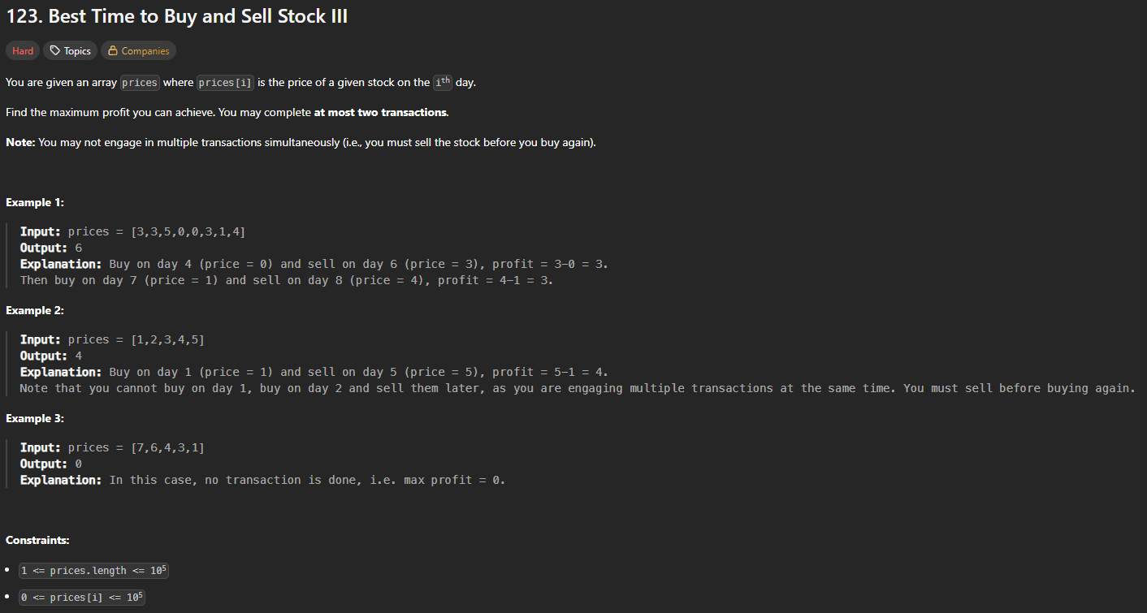

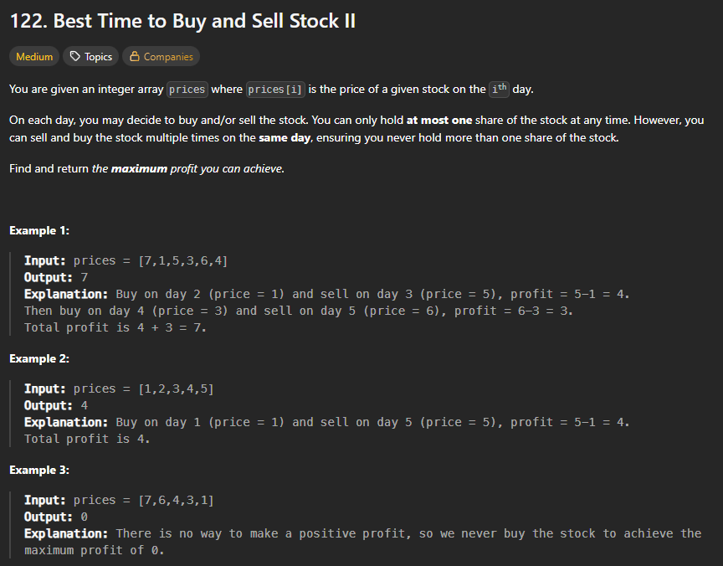

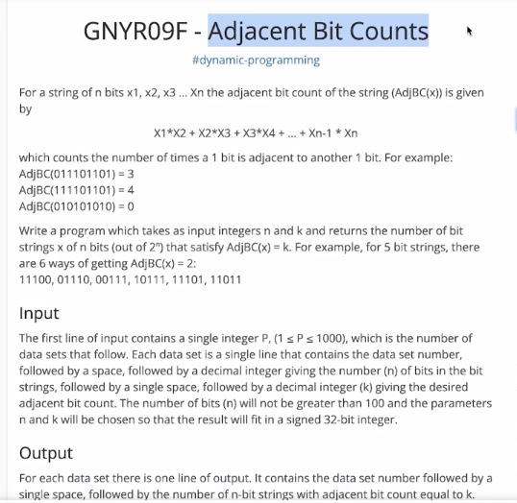

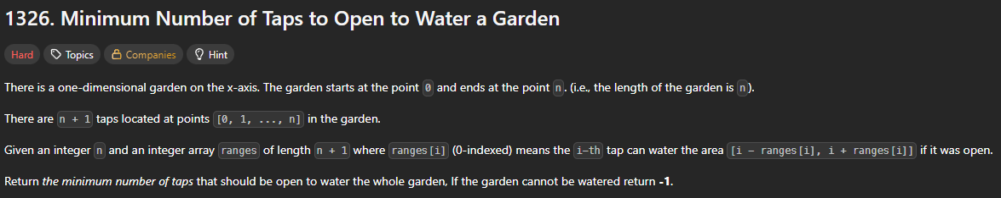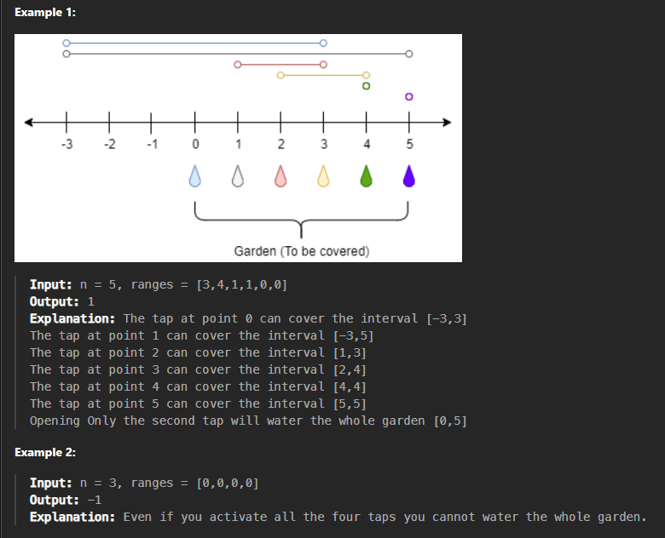

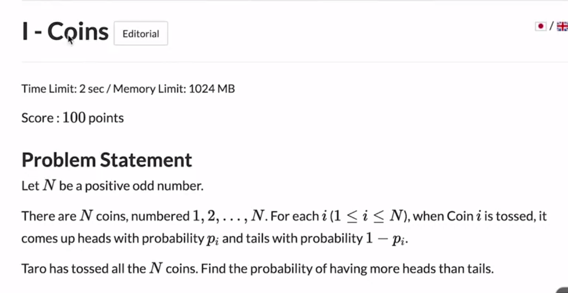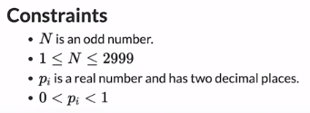

* 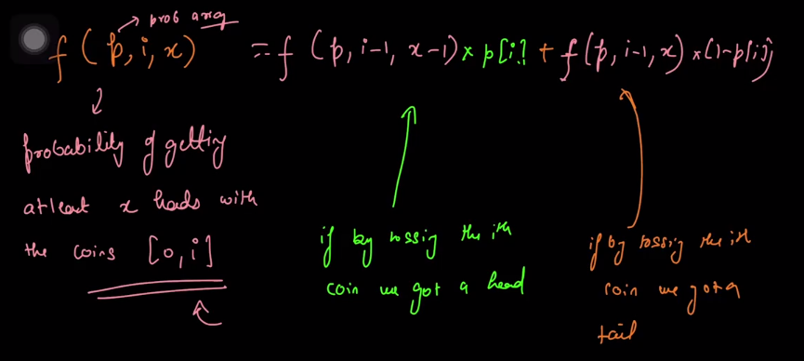

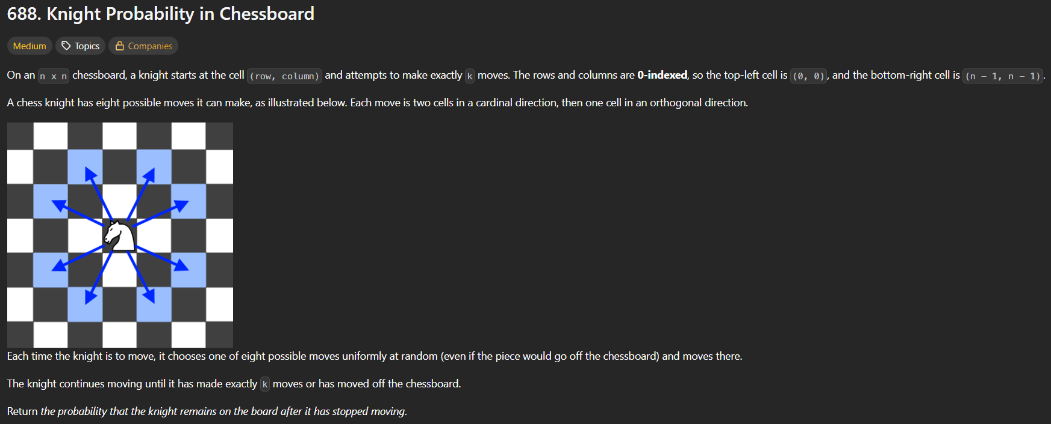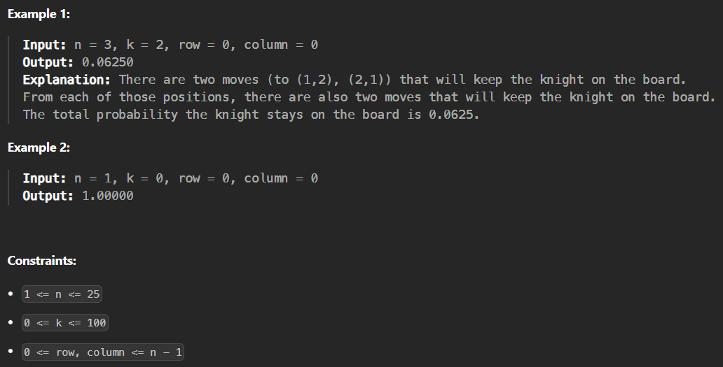

* 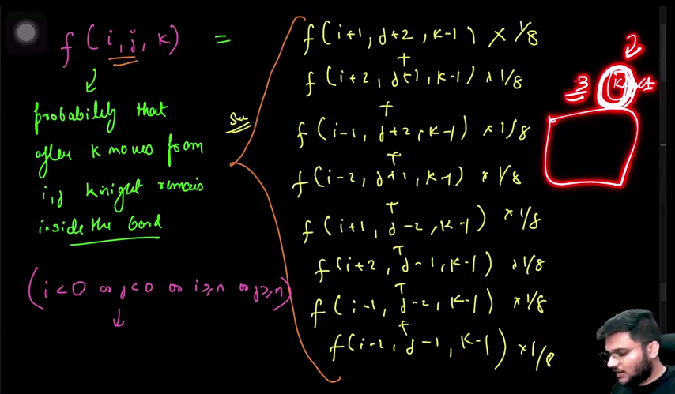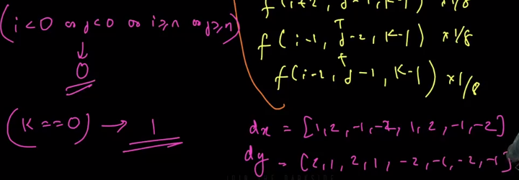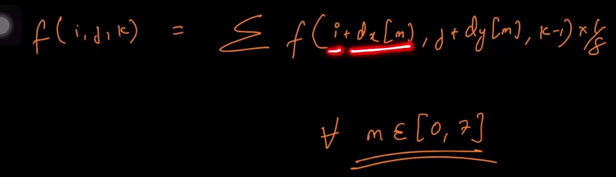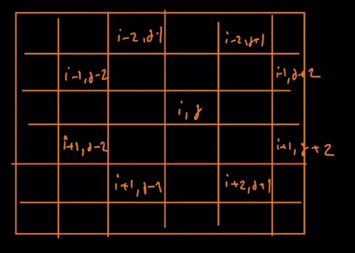

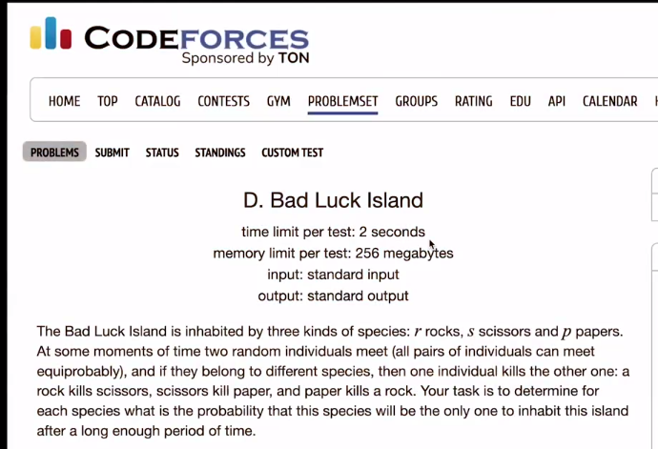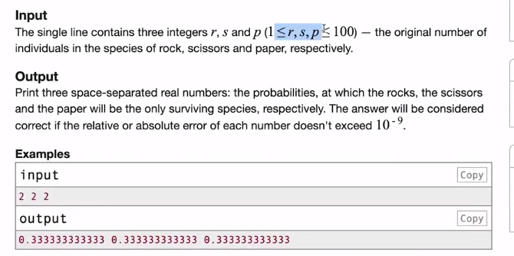

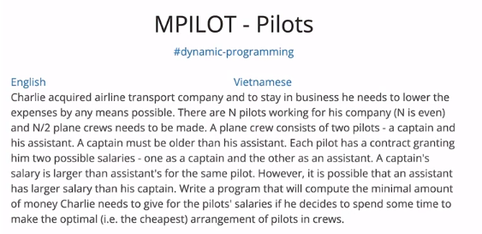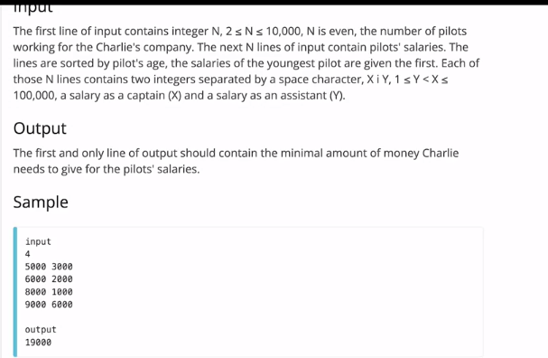

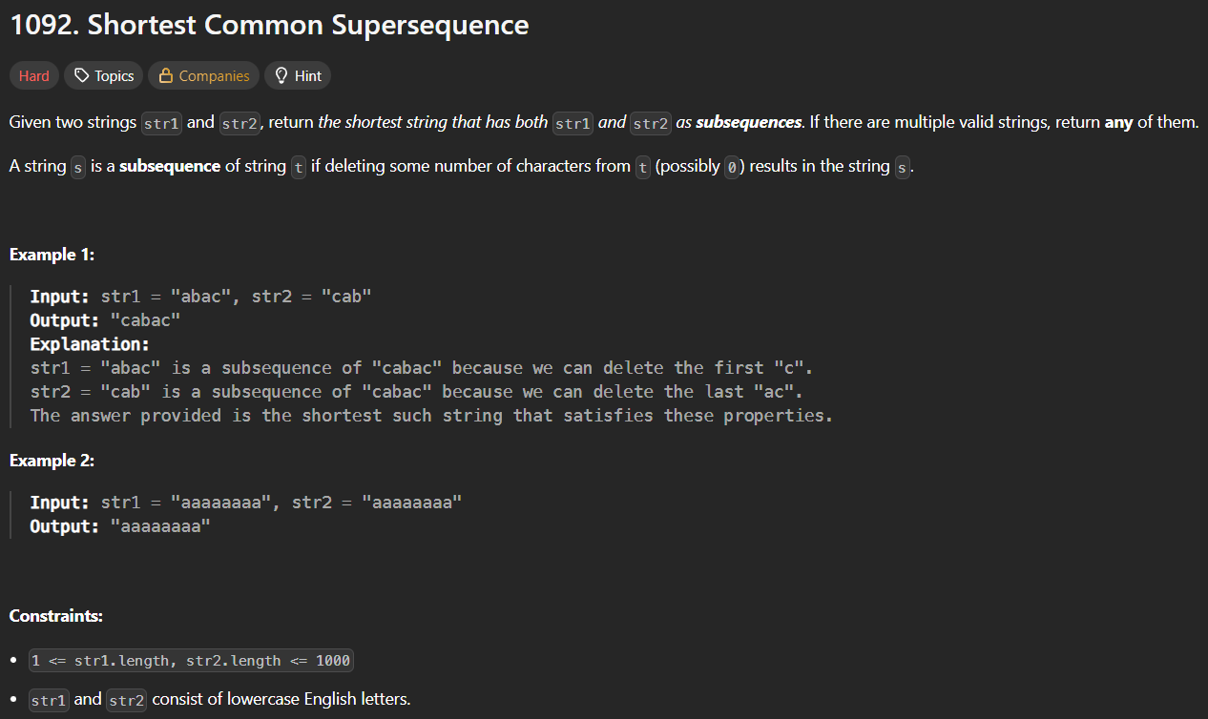

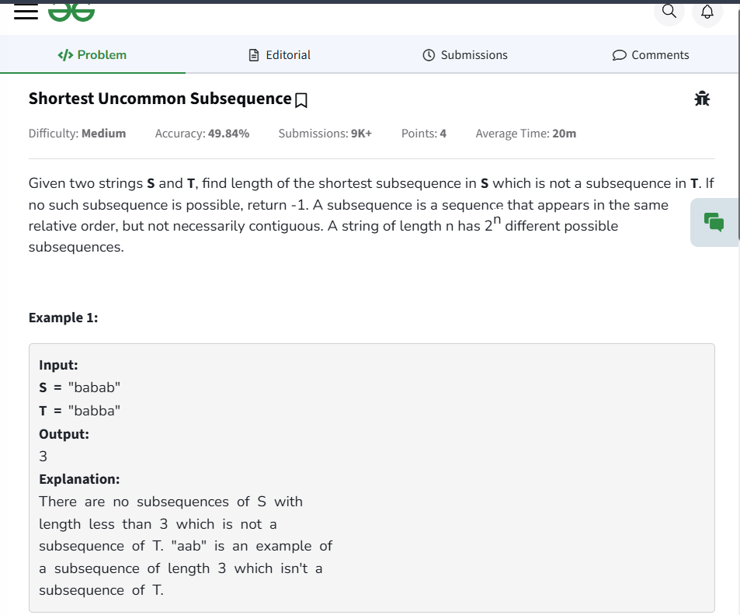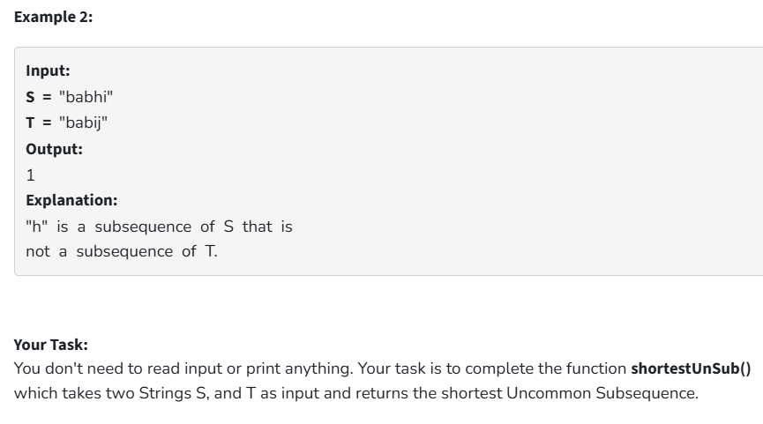

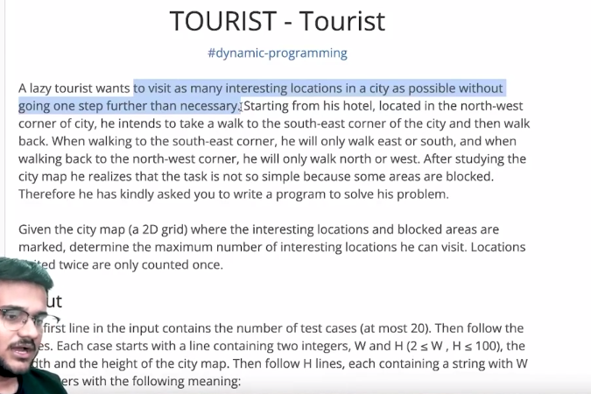

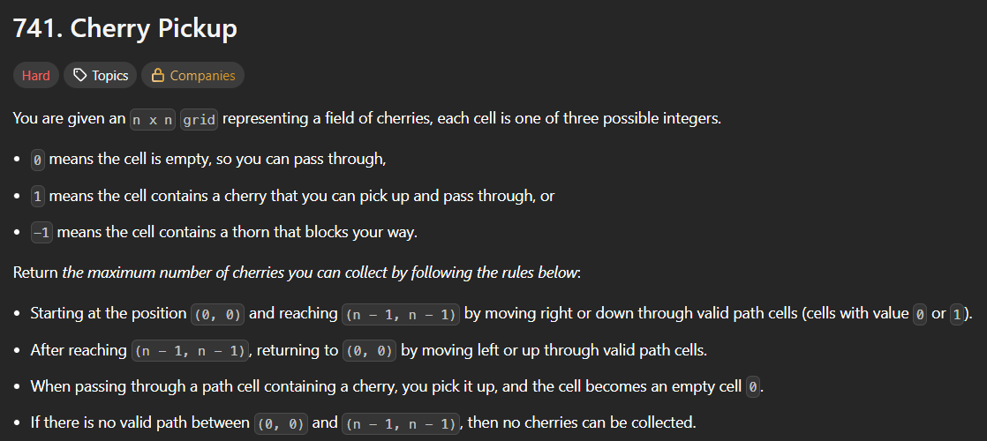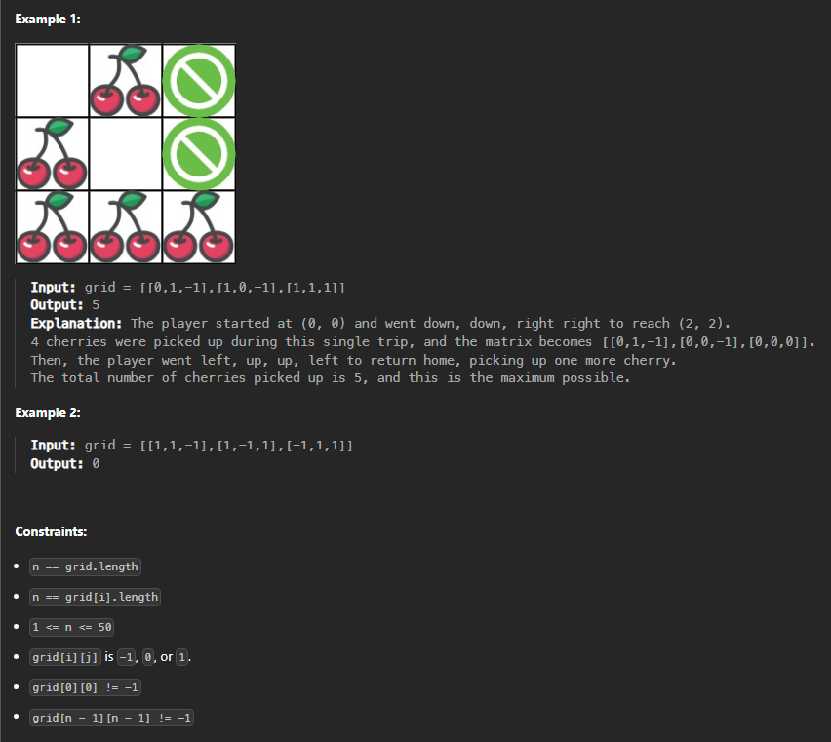🡪same as above tourist waala problem

